20/05/2019: Examining the Video Footage of June Miller (2017)
In just the first two minutes you can clearly see that this object has changed its geometry various times, and each new shape is completely different from its previous form.
Let me illustrate my point with an example of a helium balloon representing a cartoon character dog form and all its detailing; at this range, no matter how many times the balloon turns on itself in the breeze, it will be always perceived by the onlooker as just a novelty balloon.
This is not the case when studying the video from 2017 filmed by June
Miller, with the appropriate equipment for properly evaluating such.
Below are screenshots taken from the video:
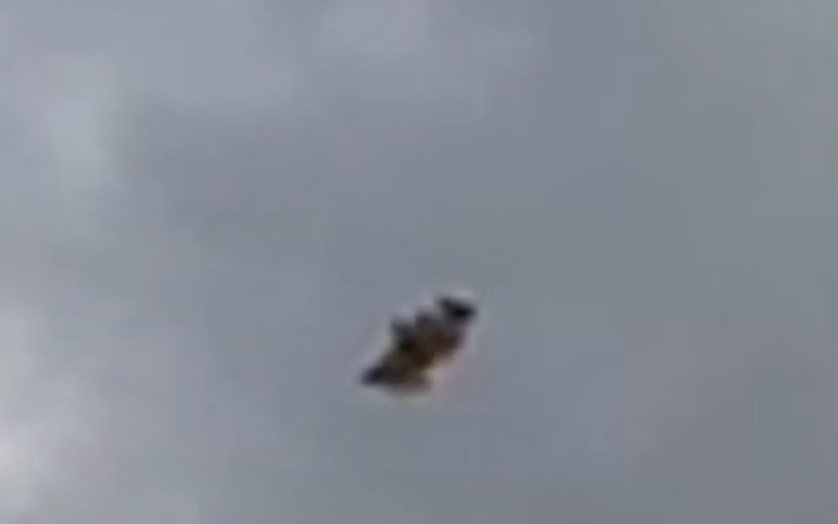
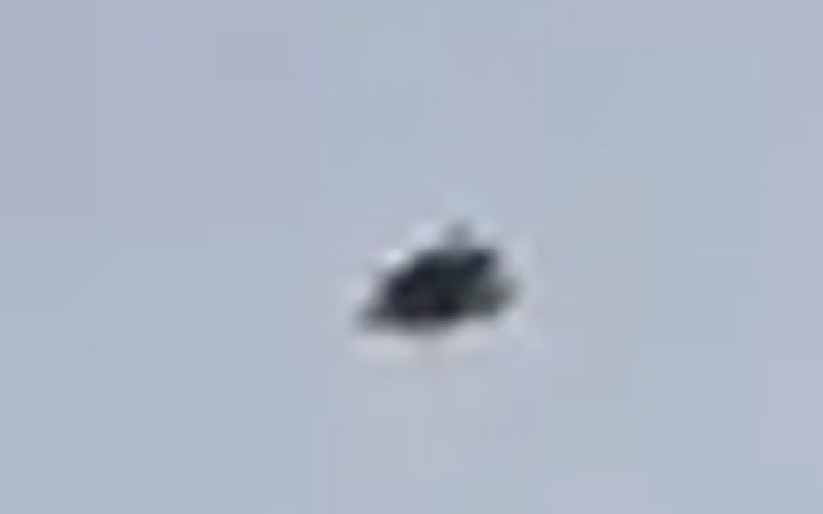
Another fact that clearly shows that this object is not a mere novelty helium balloon of any kind, is the fact that from minute three onwards, the object appears to slow down incredibly in its speed and clearly starts hovering around gently.
Till the end of the witnesses’ seven-minute-long video, this unidentified phenomenon seems to behave that way; something that wouldn't happen to a stray helium balloon.

If any helium balloon was floating through the air it would just erratically float away with some wind-current, before drifting to a higher altitude until the atmospheric pressure is decreased enough to make it explode.
A balloon would not stop and hesitate to hover for some time at a point, before continuing its journey on a steady flightpath, in a seemingly controlled manner, as the object is seen to do in this video.
The fact is that the journey is long for any such balloon, as an article from Science Focus (The Home of BBC Science Focus Magazine) by Robert Mathews so describes:
"As a balloon ascends, the pressure of the surrounding air drops while the helium inside expands. Toy balloons burst at around 10km, while professional meteorological balloons reach heights of 30km. (...) The ultimate limit is set by Archimedes Principle, which says balloons will stop rising once their density matches the surrounding air. "
Source: https://www.sciencefocus.com/science/how-high-can-a-helium-balloon-
float/
The nature of helium is very light weight-wise and lot thinner than air. That is the reason why helium enables balloons to float a lot better rather than with common air. There is no time for stopping midway as it constantly climbs its way onto the atmosphere till it bursts out.
Other screenshots are shown below:
(The one in the bottom right is exactly the same as the one on the bottom left, however the right has an added red rectangular effect to help understand the
shape this object attains.)
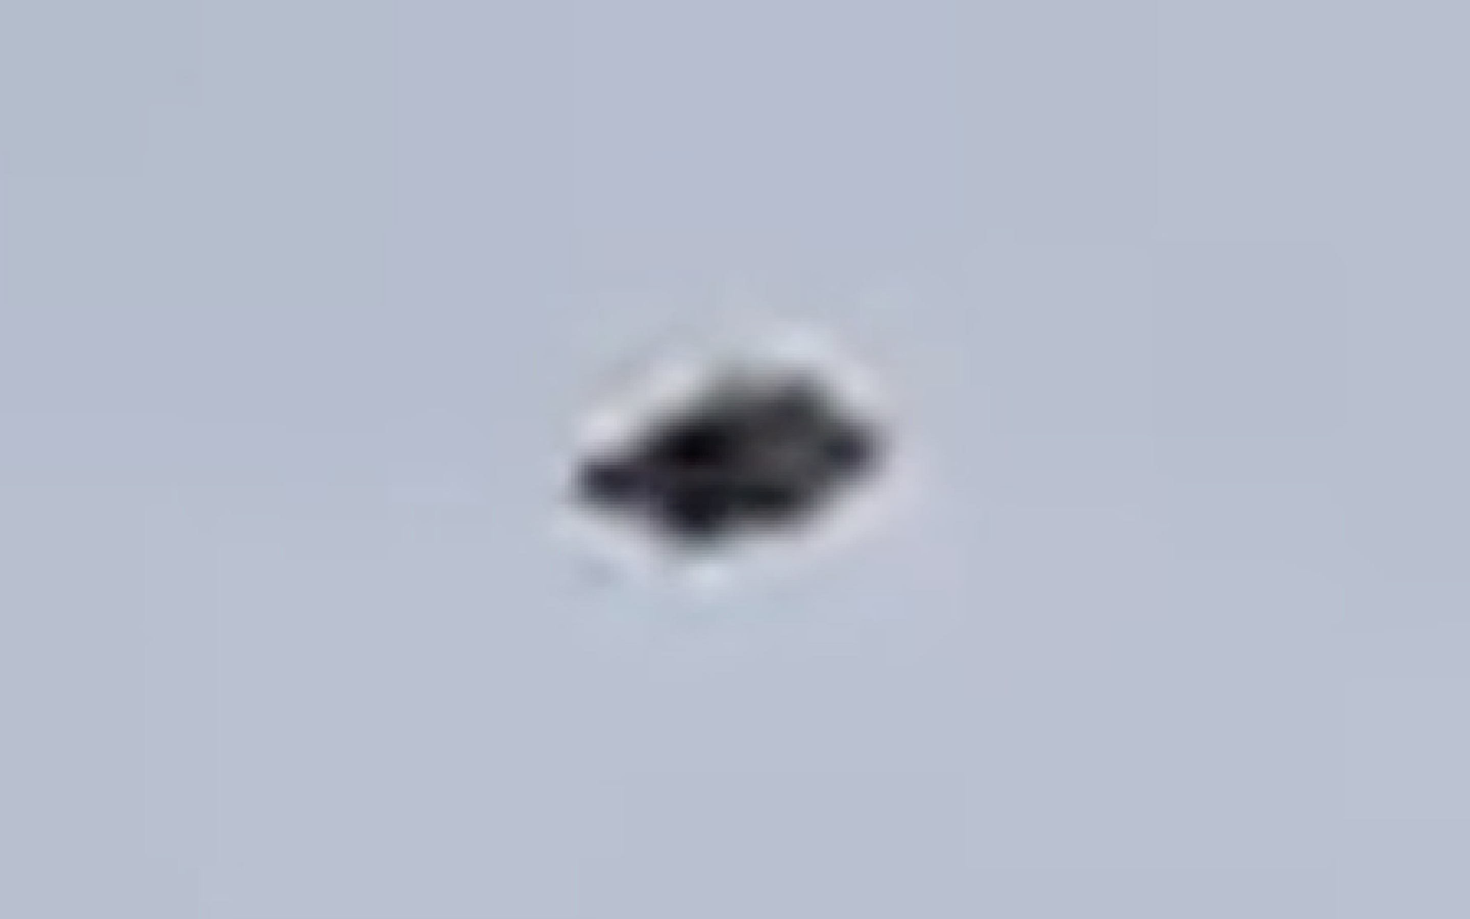

Last but not the least, what makes this video so compelling is the sheer length of it.
The majority of video evidences existing in the public domain at this time, besides being so scarce, are usually very short compared to this seven-minute-long video footage.
It is obvious that wind currents play a big a role in helping the balloons to fly out faster than they normally do; but independently of that, and of the fact that this was filmed in a very windy location such as the U.K., seven minutes would be more than enough for any helium balloon that got loose, to disappear from sight.
There is absolutely no evidence to suggest that this video is a hoax, or that this particular unidentified flying object is a drone, stray inflatable, decoration or any other manmade artefact.
Tomás Fidalgo
B.E.A.M.S. Investigations

