Useless Eaters Slyly Culled
By Ken Parsons and Hilary Porter
Most books of this genre often span 4-500 pages or more; although over half of those are probably what could be termed as a little long-winded to say the least… full of padding and waffle to be honest.
Ours is more condensed, because quite frankly we just can’t wait to reveal our conclusions to you dear reader!
If you don’t like the truth watch out! close the book now and take cover, because the facts coming your way will be as subtle as a swinging sledgehammer!
True to our word let’s get to it!
We recently discovered that the Greek word “pharmakeia” was used in Galatians 5:19, the main definition of which is “the use or then administering of drugs”.
In some translations it is described as “witchcraft”.
What do you think could be the reason for that?
Is it a warning?
The Greek word ‘pharmakeia’ used in Galatians 5:19. is generally defined as “witchcraft, magic, the use of spells and potions of magic, often involving drugs – a magic spell.
So, we ask, are the ‘big pharma’ of today attempting to cull a large chunk of the ‘useless eaters’, (as you will see we have been called) the infirm, the obese, the old… those who are weak, slyly through their sorcery? Hence the title.
11 Questions You Can Ask Your Family And Friends That Will Wake Them Up
***All facts, citations and reference material are organized and sourced at www.TimeToFreeAmerica.com
1. Why Is Congress working on Legislation HR 666?
https://www.congress.gov/bill/117th-congress/house-bill/666
2. Why Is Congress working on Legislation HR 6666?
https://www.congress.gov/bill/116th-congress/house-bill/6666/text
3. Why Is Luciferase in the Moderna COVID-19 Vaccine patents? Search the PDF for the word “Luciferase” –
https://www.modernatx.com/sites/default/files/US10703789.pdf
4. Why is the Centers for Disease Control recommending Nazi-style Quarantine Camps called Green Zones?
https://www.cdc.gov/coronavirus/2019-ncov/global-covid-19/shielding-approach-humanitarian.html
5. Why Is GovernmentJobs.com Hiring Isolation & Quarantine Team Consultants, Isolation, and Vaccine Strike Team Staff?
- Lewis County – Centralia, WA Isolation & Quarantine Team Consultants (PS2) – Non-Permanent – DOH5814
https://www.governmentjobs.com/jobs/3233390-0/isolation-quarantine-team-consultants-ps2-non-permanent-doh581
6. Why did Microsoft file for a patent for a cryptocurrency system using body activity with a publication number WO-2020-060606 thus making it possible for no man to buy or sell unless he has this technology inside of them?
https://patentscope.wipo.int/search/en/detail.jsf?docId=WO2020060606
7. Why does Bill Gates have a Satanic spirit cooking spiritual advisor?
https://duckduckgo.com/?q=marina+abramovic+spirit+cooking&t=hc&va=o&iax=images&iar=images&ia=images
8. What is the statistical probability of this occurring randomly through coincidence?
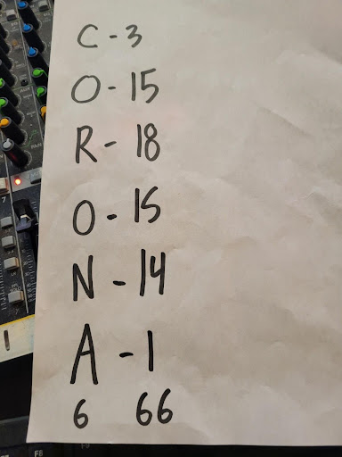
9. What does Revelation Chapter 13: 16-18 Say Again? (Revelation was written by John the Apostle while being exiled on the Island of Patmos)
16. And he causeth all, both small and great, rich and poor, free and bond, to receive a mark in their right hand, or in their foreheads:
17. And that no man might buy or sell, save he that had the mark, or the name of the beast, or the number of his name.
18. Here is wisdom. Let him that hath understanding count the number of the beast: for it is the number of a man; and his number is Six hundred threescore and six.”
10. Why Did Klaus Schwab write a book calling for the implementation of “The Great Reset” which he also calls the “4th Industrial Revolution?”
https://www.amazon.com/COVID-19-Great-Reset-Klaus-Schwab/dp/2940631123/ref=sr_1_1?keywords=the+great+reset&qid=1636200861&sr=8-1
11. Why Did Klaus Schwab Schwab say That “The 4th Industrial Revolution” and “The Great Reset” wouldn’t change what you do for a living as much as it will change YOU through “The Gene-Editing?” The Fourth Industrial Revolution and genetically modified humans
https://rumble.com/vld6yh-the-fourth-industrial-revolution-and-genetically-modified-humans.html
To subjugate popular opinion, conspiracy theories are now regularly ridiculed by the media; people have become predisposed to scoff at any ‘outside of the box’ ideas, and some rightly so; snag is, the good ones tend to get tarred with the same brush as those more outlandish.
The Internet is headed toward total censorship of “unauthorized” content as well as individuals who consume or produce such content. Once you are identified as “unsafe”, you could be banned from Internet presence, denying access to email and online accounts. A recent quote by Patrick Wood, leading and critical expert on Sustainable Development, Green Economy, Agenda 21, 2030 Agenda and historic Technocracy.
And some are not conspiracy ‘theories’ at all – but harsh reality, conspiracy facts!
Take this…
The malady known as Gulf War Illness (or syndrome) looks likely to have been caused by an illegal vaccine "booster" given by the Ministry of Defence to protect soldiers against biological weapons, according to the results of a new series of tests. The Guardian: Mon 30 July 2001
A May 2018 report by the U.S. Department of Defense, "GWI is estimated to have affected 175,000 to 250,000 of the nearly 700,000 troops deployed to the 1990–1991 GW theater of operations.
As it happens, we personally know a Gulf veteran; he has never received compensation, even though his health has been adversely affected by a whole raft of problems from the vaccinations given to him for active duty.
Next… when George Bush was asked by a journalist whether he feared that history would remember him as the bad guy, following his unjustified invasion of Iraq in 2003, and the estimated 1,033,000 excess deaths of innocent Iraqi men women and children that occurred as a result – he facetiously replied ‘no, I will simply have my guys write the history books that go into the Whitehouse Library.’
He wasn’t joking either.
Same war, British PM Tony Blair is on record as having viewed his decision to invade Iraq in 2003, as part of a "Christian battle", judging by many sources, including one of his closest political allies.
Research into Blair reveals that he was fairly quiet about his beliefs, though under the then Labour leader John Smith, he joined the Christian Socialist Movement in 1992.
Never talk about God… GB [Gordon Brown] called and we agreed God was a disaster area.
*Tony Blair's former press secretary reveals in his diaries that the ex-PM often ... dismissed questions about Blair's faith by saying "we don't do God".
Source: Crossley, James G. "45 Minutes from Doom! Tony Blair and the Radical Bible Rebranded." Harnessing Chaos: The Bible in English Political Discourse Since 1968. London: Bloomsbury T & T Clark, 2014. 210–241.
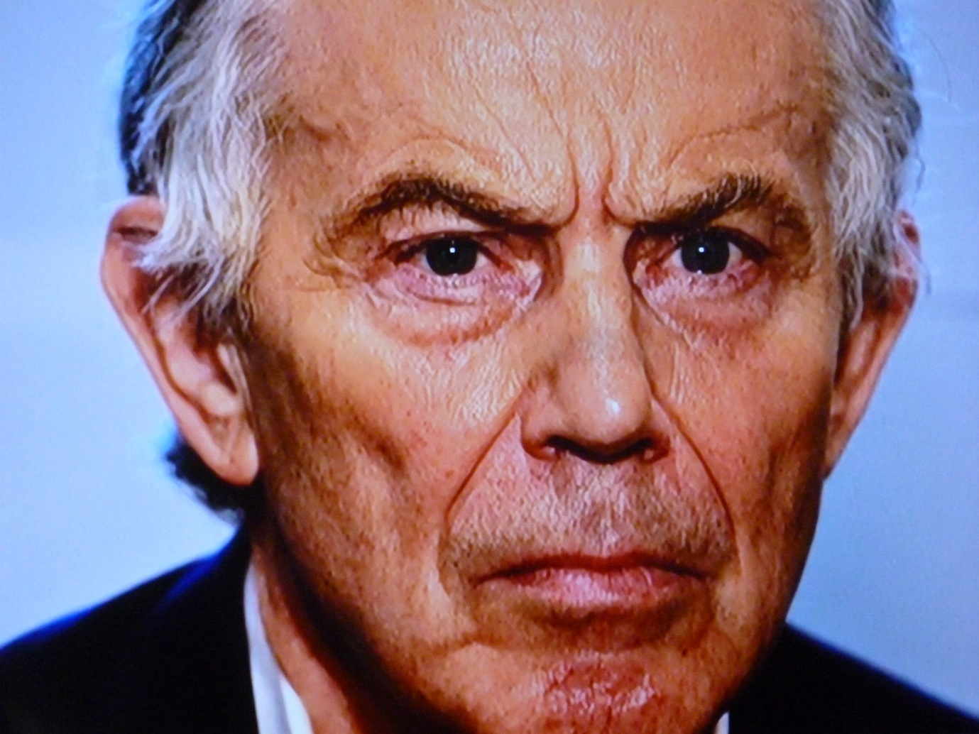
Weaponisation of fear is the currency of control. “People have got to understand that in the end, vaccination is going to be your route to liberty.” Tony Blair
“After the Blair victory of 1997 - a whole new political system, [came to power] hostile to the traditional married family, scornful of tradition and patriotism, filled with hate for Christianity.” A quote by Yeonmi Park about her time in the UK, featured in Peter Hitchens’s Mail on Sunday column. 19 June 2021
“We will decide who lives and who dies” – Gordon Brown, (Former British PM) speaking in 2021 regarding Covid-19 vaccines and Common Purpose - a British-founded charity that runs leadership development programmes around the world.
Yes folks, he REALLY said that!!!!!!!!!!
‘G7 leaders to decide 'who lives and who dies': 7 Jun 2021 — "And on Friday at the G7, we will decide, effectively, who lives and who dies - who is to be vaccinated and is therefore safe and who is not” ... Sky News.
Such statements are indicative of internal trains of thought, secrets that are not really meant for public consumption; but some people just can’t help themselves; and like all good high-ranking Masonic members, they HAVE to reveal their intentions; bragging almost, yet effected in an elaborate way.
These are shady characters; very few would disagree with that assessment, and yet they are just the tip of political cult immorality.
Be honest, are these the sort we want lording it over us - the plebs – as they may call us?
Any good forensic linguist would confirm, that slips of the tongue like Gordon Brown’s, are sometimes a dead giveaway of a criminal mind.
Our impression when hearing things of this kind, is that behind all their smiles and suits, the figures running our world are a filthy-rich elite, fascists and possibly psychopaths to boot.
We’ve heard that the intelligence services usually have some kind of ‘dirt’ on certain ‘people of importance’, meaning that they are on a tight rein under the constant threat of blackmail.
This ‘dirt’ represents a perversion of some kind… namely through involvement with demonism and the dark things these guys and gals do.
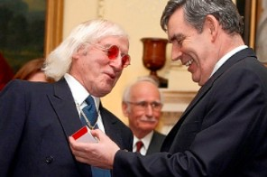
Ow's about that then?
In politics, creatures like him become leaders of Her Majesty's Government because they can be easily manipulated by threat of being exposed; because they believe in a "God" which bears no resemblance to the real God.
And when the deep state has no use for these pawns, once they have served their purpose, they are metaphorically pushed under a bus. Just look at minister Matt (hypocrite) Hancock and that infamous footage which forced him to resign; how did the leak happen? the indications are he was set up for a fall.
Yet, although they may fall from public grace, quietly they step right into another well-paid position; cushioned by their huge pensions, perks and portfolios, these people are never really punished… they are not made to atone for their crimes – not while here on earth anyway.
It is all about sacrifice; his demise was a symbolic sacrifice, in our case, (as you will read) it’s physical… human sacrifice.
Thing is, most MSM bases are now covered to keep the true colours of prominent cult individuals hidden; in general, we only get to see what they, (these types) want us to see.
Any tell-all leaks, any illuminating faux pa’s, any glimpses of public figure malevolence are tightly restricted… until that is, it suits the puppet masters.
A warning shot across the bow of any would-be promoter of ‘conspiracy theories’. Anything too damning is either blocked, removed, or otherwise hidden from public view; social media users are cautioned or banned, content and accounts deactivated.
It’s occurring all the time.
Communications Act 2003, Section 127 - Legislation.gov.uk
Section 127 Improper use of public electronic communications network.
(3) A person guilty of an offence under this section shall be liable, on summary conviction, to imprisonment for a term not exceeding six months or to a fine not exceeding level 5 on the standard scale, or to both.
This includes serious intent to cause harm or incite hatred against others.
But the definition of harm is incredibly broad and is now being used to cover ‘disinformation’ and’ misinformation’ about the novel coronavirus, COVID-19.
Search engine, social media platform and app companies are having a field day, punishing users, for doing and saying things which clearly don't even come close to breaching official rules.
Someone recently said “I've never known so many friends get a two week ban from Facebook for the most innocuous reasons. Apparently, you aren't even allowed to say "fat" these days, no matter what the context is.”
Hilary and I noticed this Section 127 being enforced in a big way from around the beginning of the so-called ‘Coronavirus Pandemic.
Suddenly, it was as if a censorship net had come down over most media.
Today, practically all the material we get to see and hear on the TV, in papers, on the Internet etc., has become so nauseatingly truth-disinfected, that revealing remarks like the aforementioned, and any embarrassing political truths, are rarely seen by the public at large.
Currently, damaging revelations can so easily be, (and often are) re-branded as ‘misinformation’, ‘fake news’, then fail Broadcasting Guidelines, and therefore hardly get the mainstream coverage deserved.
The press is rightly accused of suppression and censorship.
At many media levels, cleverly choreographed deceptions are standard; some of these are prodigious, but often cleverly laced with some grains of truth for best effect.
We reckon that the uninformed, unsuspecting public are being had, with the average person left so confused that they become emotionally detached to it all.
It’s a ‘mind-blindness’ as it has been termed.
More and more are becoming subconsciously ‘blind’ to all the lies and half-truths fed to them.
What many believe to be fact is at least partially wrong; they are taking as fact, a cleaned-up version of certain matters – a perverted simulacrum.
Though, it is not just the present age that is being truth-washed - no; history has been written, re-written, reimagined, reinvented and manipulated by wealthy influencers, so many times, that much of it is just that… a story; his-story, the story according to whatever ruler happened/happens to be in charge at the time!
Next generation, these distortions are then taken as gospel and repeated, parrot-fashion by our educators!
The network evening news, (for us here in the UK it’s usually ITV or the BBC, (the Brainwashing Broadcasting Corporation as we call it) are all supposed to be fairly impartial; but they’re not; a better description would be government constrained commentators.
Section 336(5) of the Communications Act 2003, enables, (amongst other things) our censorship-obsessed Government, via the regulator Ofcom, to hold sway over the BBC.
No matter how polite, how well-spoken, how friendly the presenters may appear… it is a charade; when it comes to the most important stories, complete, unbiased news information is hardly ever delivered anymore on the BBC.
Same applies to Sky, C4 and ITV… their newscasts are so sterile and dumbed-down, such one-sided overkill, we find them virtually unwatchable.
“Presenter leaves BBC after 'calling it the devil'.
Jemma Cooper - who worked for the BBC as a weather reporter from 1999 - is no longer working for the broadcaster. It comes after she took part in anti-lockdown marches and admitting to drink-driving.” Mirror April 15, 2021
BBC = “The Devil” eh?
Couldn’t have put it better ourselves.
We watched Jemma on an interview, and she is of the opinion that her employers, (sometimes called ‘the Beeb’… more like Beelzebub, lol) have a ‘dark energy’ about them’; they treated her ‘like a heretic just because she had a difference of opinion’ concerning the so-called vaccines and the ‘pandemic’, then ultimately ruined her career.
When working there, she tried questioning the narrative, and was told in no uncertain terms ‘you can’t touch Covid’.
Jemma revealed that she isn’t on any social media anymore either, adding that Facebook in particular, ‘was evil’.
She made it clear, the flow of C-19 information is now being completely monopolised by corporate media.
This includes the Internet and the daily rags… newspapers.
We suggest that specific areas of their news are also subject to regular manipulation/whitewashing.
Communities who disagree with what is going on in terms of this censorship of the British media are obviously unrepresented; voices of dissent are muffled and go unheard.
That is why public trust in the mainstream media has fallen off a cliff.
Very few want to see a misrepresentation of reality.
We live in an age of global dishonesty and delusion of epic proportions.
For some in high places, deceit is a way of life. Duplicity has become an art form.
Corruption of the truth is almost everywhere.
But it’s weird, why some of us have not been programmed by our daily diet of news media brainwashing and misinformation; somehow, perhaps using our sixth sense, we can see through the psychological manipulation, social influence, engineering, and censorship.
And when we say ‘others’, we don’t mean just a few – this adds up to public concern on a global scale!
The world is divided.
One only has to examine the linguistic weaponry that is being used across the board… the Internet, Social Media platforms, newspapers etc. It’s suspiciously clinical and uniform to say the least. It’s almost like reading from the same script!
There are those of us who pay heed to an inner alarm bell, warning that what we are sold by the media is heavily strained; like having been fed through a discretion filter and much of the succulent fact-pith removed.
News presenters speak in pleasant, but emotionless tones as they read autocue text; but are we right to believe what we hear?
No, no, no.
They may tell you what you want to hear; maybe entice you to watch more with an item of interest, (perhaps a puppy or a fluffy kitten story) but that is just the lure, as the sucker viewer is taken ever further down the Covid rabbit hole.
It’s blatantly obvious who spins the wheel, and the game is rigged.
As far as we are concerned, these sickly-sweet, propagandist, government-approved media, ‘safe’ presentations, fail to hold our attention and are no longer fit for purpose.
And now over to the weather, and now the sport, and now a word from our sponsors… a commercial break – someone pass the sick bucket please!
High levels of censorship are evident on most platforms; government interference is absolutely rampant, especially when it comes to Covid-19 information!
“Tory MP Desmond Swayne accused of telling anti-vaccine campaigners Covid figures are being ‘manipulated” Evening Standard - January 18, 2021
“A senior Conservative MP has been accused of spreading “dangerous misinformation” after reportedly suggesting that the scale of the coronavirus pandemic was being exaggerated.
Sir Desmond Swayne urged anti-vaccination campaigners to continue fighting against restrictions and told them NHS capacity figures were being “manipulated.” according to Sky News.”
The actor and comedian Sacha Baron Cohen once attacked social media platforms, describing Facebook as “the greatest propaganda machine in history”.
That wasn’t satire. Giving the speech, Baron Cohen appeared as himself, rather than one of his characters, and Cohen was totally captivating in his seriousness.
His scorching tone showed that he meant business.
In a way, we’re all under a spell - the spell of language… spelling; you see it’s often in the wording, (e.g., understanding v. over standing) and presentation.
Where does the deceit stop, and tyranny begin?
It has been widely stated that the current method of *gaslighting, withdrawing, censoring, and banning, is deliberately designed to cultivate consensus, in order that the flock obediently accept what they are fed information-wise, unquestioningly gobbling up everything presented to them.
*Gaslighting: Using denial, misdirection, contradiction, and misinformation, gaslighting involves attempts to destabilize the victim and delegitimize the victim’s beliefs.
It is believed by some, that ‘fact checking’ is being used by both mainstream media and big tech companies in cohort with their political associates to interfere with and misinform the general population. It started with prejudiced media outlets from where it spread first to platforms such as Twitter and then Facebook which have been removing inconvenient opinions and facts under the pretext of ‘fact checking’.
Not surprisingly, their decisions are often unilateral and there is no one properly scrutinising the ‘facts’ of the ‘fact checkers’… of which, many can be traced back to having some connection with government agencies… and governments around the world are investing billions into selling the Covid message.
We are all prone to believing information when it is repeated and easy to process.
Conducting your own deep research, (as best you can) is the only solution.
“If you tell a lie big enough and keep repeating it, people will eventually come to believe it. The lie can be maintained only for such time as the State can shield the people from the political, economic and/or military consequences of the lie. It thus becomes vitally important for the State to use all of its powers to repress dissent, for the truth is the mortal enemy of the lie, and thus by extension, the truth is the greatest enemy of the State.” Joseph Goebbels.
This is Brainwashing, (also known as mind control, menticide, coercive persuasion, thought control, thought reform, and re-education).
So, how can we believe anything we read or accept any mainstream ‘facts?
We can’t - hence the background of anxiety within.
Beverley Turner is an English television and radio presenter; interviewed by Alastair James Stewart OBE, journalist and newscaster, via a video link, she spoke out on GB News 27/06/2021 about how there is ‘a vacuum of silence’ regarding the full facts of the Covid vaccine – and how it was making large numbers of recipients poorly.
She confirmed how ‘Ofcom will allow nothing to be broadcast which questions the efficacy of the vaccination programme’, creating a virtual news blackout of the truth.
Then, just as she was getting warmed up, she was cut off early, with Alastair saying, ‘thanks Bev, we must park it there.’
Unbeknown to Stewart, Bev’s microphone feed was still on, and she was heard to scream furiously in the background ‘is that it?’
The very next story on that programme was about assisted dying – euthanasia! – unbelievable or what?
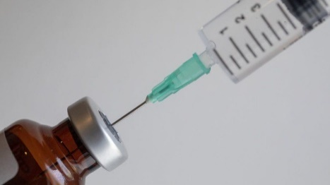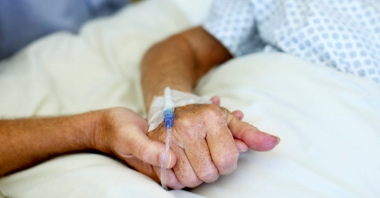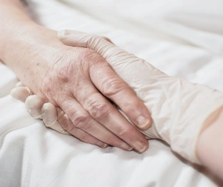
Could be a coincidence, yet to us, it was almost as if they were subliminally telling all viewers about the human cull.
But where to look for more answers, with so much censorship going on.
Bottom of Form
One way of finding meaning, or at least comfort, in these chaotic times is through a Biblical perspective, in amongst its numerous narratives.
Believe it or not, The Bible even seems to allude to Brainwashing.
Romans 12:2 Do not be conformed to this world, but be transformed by the renewal of your mind, that by testing you may discern what is the will of God, what is good and acceptable and perfect.
Cynics may argue that all Bibles’ of the world are fabrications; inventions designed to control people through fear; but we disagree with that assessment, as much of what is mentioned in the holy scriptures, (characters, places etc.) has been proven through archaeological findings.
It is commanded that the content of The Bible, (or any Bible come to that) shouldn’t be changed; it is said to contain the actual words of God or The Godhead, (also called ‘godhood’, which is the divinity or substance, of the Christian God) given through divine sources; it is a rule book, a reliable collection of historical documents written by patriarchs, prophets and/or apostles of God during their lifetime, and purposely left clues about their predictive visions.
The divine wisdom of God the creator, applies to then, now and the future.
Yet, many have defied God’s rule; there are a multitude of different renditions or ‘versions’ of the Christian Bible in existence; so many adaptations of the word of God that it’s difficult to calculate the exact number, although estimations have it at more than 2500 variations on the Bible theme!
Not only this, but policing/censorship/revisionism/modification has also been a part of this great work; and logic dictates, that if Biblical texts are mere ‘fabrications’, then why has so much effort been put into altering them?
Certain religious books have actually been ‘lost’ – or are missing from some Bibles’… the Apocrypha as they are known.
These include:
Baruch
Book of Tobit (the Vulgate, and Luther call it "Tobias")
Book of Judith
Book of Wisdom
Ecclesiasticus
Esdras
Susanna
1st & 2nd Maccabees
The Apocrypha are religious texts that are in some versions of the Catholic Bible. Other versions omit them. The word comes from Ancient Greek ἀπόκρυφα (apokrypha). Apocrypha means those that were hidden or secret.
Generally, the term is applied to writings that were not part of the canon; but, having said that, the ‘Apocrypha’ was in every Christian Bible right up until 1828.
These secret texts were removed in 1828 from a limited, (though considerable number) of Bibles’, because among other things, (or so the excuse goes) that they were not Divinely inspired.
Ironically, in the Apocrypha (Second Maccabees 12:41-45) it says… the ways of the Lord, the righteous judge, who reveals things that are hidden.
And then someone decides to go and hide these doctrines.
If that doesn’t amount to censorship, then what does?
Who on earth did/do those high academics think they were/are to alter and withhold any divine, or divinely inspired wisdom like that?
The idea of the body as a weight upon the soul is found in the Apocrypha.
For a perishable body weighs down the soul, and this earthy tent burdens the thoughtful mind (Wisdom 9:15).
Having had numerous spiritual Out of Body experiences ourselves, we can confirm that what is talked about in this section of the Apocrypha is the same soul/spirit body thought to separate and travel remotely, during Out of Body Experiences, (or OBE’s, sometimes also termed Astral Travelling) and is even thought to survive physical death; the ghost within as it were… the immortal body.
And the physical body does indeed weigh down the spirit body.
When the ethereal spirit soul returns into the physical – well, we have heard it described, (and we agree) that it’s like entering a cumbersome lump of meat.
Upon re-entry, one temporarily feels heavy - is the only way we can define it.
Upon death - the old expression of giving up the ghost is an impeccable clarification.
Surely to withhold such knowledge is a sin – but then again, are we not all sinners?
We should all admit this before God.
Romans 3:23: for all have sinned and fall short of the glory of God.
Yet, as someone, (can’t recall who it was) once said, ‘this is a world in which everything is forbidden unless it is explicitly permitted.’
We are, and have always been, at the mercy of the truth police.
And it has to be wondered what else, (perhaps under the instruction of whichever ruler was in charge at the time) has been removed from religious texts worldwide.
Not just the Christian/Catholic bible – but all Bibles’, of all faiths.
In these numerous ‘versions’, we find examples of cuts, mistranslations, paraphrasing and modernisation etc, etc.
Surely though, if we, (someone) disagree/disagrees/disagreed with something in any Holy Scripture, it's not the wording that needs to change – it’s the examiner.
Proverbs 30:5-6 states… Every word of God proves true; he is a shield to those who take refuge in him. Do not add to his words, lest he rebuke you and you be found a liar.
and
Deuteronomy 4:2 warns… you shall not add to the word that I command you, nor take from it, that you may keep the commandments of the Lord your God that I command you.
But why do we continue to see so many variations? Maybe because, as it is written, the plans of His heart are for ALL generations. His Word is Timeless and His Promises Are Everlasting!
Yes, fashions change as humanity evolves, and fundamentally, the Bible tends to be decoded according to the times we live in.
The Bible has no sell-by, use-by or best before dates.
In many respects, it is as relevant today as when it was first written.
If one knows how to search for hidden or interwoven messages within religious texts then they will be found; for instance, one may see ‘soul’ as also being used as a coded substitute for the word ‘energy’.
That’s not changing but deciphering… trying to make sense of it all.
One movement which originally hailed from Ethiopia, who promoted a bizarre and complicated theology, (whose meetings we used to attend during our early research) taught us, that to them, Genesis really means the Genes of Isis. This is because the original story in that so-called first book of the Bible is really an Egyptian account written thousands of years before the Bible and was taught to initiates in the great Nile temples. Moreover, the syllable Gen means "woman" or "Queen".
This is, what was for them, Sound Right Reasoning.
Indeed, mulling over the very foundation of words, stripping them back to basics, rather than going with what we are taught today, can sometimes prove a useful method when searching for original meanings.
Gene-Isis is said to be a Sacred Genealogy only known to initiates.
With that in mind, clearly The Bible has been adjusted to suit.
These alterations are not progress, but truth decay.
Revelation 13 verse 18 speaks about using wisdom and understanding a certain matter that will not be apparent. We know that Revelation 19:20 clearly tells us that people WILL BE DECEIVED into taking the mark.
This will mean that no one can buy or sell anything without that mark; does that jog your memory about something?
A cashless society springs to mind; after all, when was the last time you used real cash notes and coin currency; also, note how many of the ATM’s are being withdrawn.
And while not directly alluded to in Scripture, the Covid-19 debacle may be a forewarning that man is going to be fooled; proving that he is not so high and mighty as he sometimes likes to think.
Matthew 24:21 For at that time there will be great tribulation, unmatched from the beginning of the world until now, and never to be seen again.
As most people are aware, in Revelation 6:2-8 we have The Four Horsemen of Apocalypse representing War, Famine, Pestilence and Death.
Then there are the Biblical roots of ‘lockdown’.
The word ‘quarantine’ comes from the Latin quadraginta and the Italian quaranta, both meaning “40 days”. We believe that this word of anxiety was deliberately chosen by our leaders because of its strong Biblical foundations.
The number 40 occurs many times and in lots of contexts in the Bible, but although every case is different, most of the Biblical periods of 40 relate to the single notion of testing.
Revelation 13:16-18 also hints at the future.
First let us look at the attributes of God. He is all knowing; omnipotent, all powerful; omnipresent. Whereas the devil is not physically omnipresent, and he requires an artificial system which would allow him to monitor every single human being… what we would term a Surveillance Society.
His ultimate desire is to completely control, track and monitor the global population; but to do this he must first eliminate the use of cash.
The number of the beast is described in Revelation 13:15–18. Several translations have been interpreted for the meaning of the phrase "Here is Wisdom. Let him that hath understanding count the number of the beast..." where the peculiar Greek word ψηφισάτω (psephisato) is used. Possible translations include "to count", "to reckon" and also "to vote" or "to decide".
17|: And that no man might buy or sell, save he that had the mark, or the name of the beast, or the number of his name. 18: Here is wisdom. Let him that hath understanding count the number of the beast.
Revelation 13:18 tells us that if one is wise and has an understanding to count the number of the beast, which is also the number of a man, (imitating the Son of man, Jesus Christ), the number comes to 666.
Now, Go Compare: Have a look at this from the official Congress.gov site.
https://www.congress.gov/bill/116th-congress/house-bill/6666/text
H.R.6666 - COVID-19 Testing, Reaching, And Contacting Everyone (TRACE) Act.
But wait… a bill must be passed by both the House and Senate in identical form and then be signed by the President to become law.
Bill numbers restart every two years. That means there are other bills with the number H.R. 6666 as well. This is the one from the 116th Congress.
Just another coincidence, a conspiracy theory? Big Brother’s ability to track virtually every human being on the planet? Vaccine Passports?
The media say there is confusion as to the origins of SARS-CoV-2 which is said to cause the Covid-19 disease.
Was it manmade, maybe as a bioweapon, either escaped from a virology lab in Wuhan, China whilst conducting experiments there, or deliberately released?
Or is it a freak crossover virus that has come from bats to humans?
Or is C-19 an outright lie? – a historic scam using a re-designation of other diseases, the normal range of diseases that are always there? and do people at the heart of government decision making, know COVID-19 is not what it is purported to be?
Something which quite a few professionals have tried to speak out about, but who were quickly criticised for their “outrageous and irresponsible” comments from every quarter; and subsequently had their lives ruined by the deep state and the goffers employed by them, by either being sacked, banned, barred from practicing... blacklisted, bankrupted, effectively silenced.
Any of these scenarios could have been seized upon to control society and kill-off a percentage of the population; perhaps in order to balance the books, so to speak.
Although it may beggar belief that anyone would dare even suggest this, we get the distinct feeling of a deception and a cover up; and there are many others out there who are of the same opinion.
Hitler back in WW2, implemented a eugenics or population reduction program.
Pick any philosophy you like, but whichever one you side with, there is no escaping how some powerful people in the world are exploiting the pandemic in some way.
Not long ago, The Guardian newspaper revealed in one of its pieces, how the British government ran an exercise modelling the impact of a coronavirus epidemic, four years before the Covid-19 outbreak even happened! but they tried to keep it secret.
It was one of 10 previously unpublicised pandemic planning exercises in the five years before Covid-19, now quietly disclosed under freedom of information legislation.
This damning revelation has since been swept under an ever-bulging ‘privacy’ carpet by the new wave of media suppressors.
Government officials had previously declined to reveal details of the exercises, citing the need to safeguard national security.
Well, call us conspiracy theorists if you like, but information like that is enough to make anyone think twice.
We are not alone; other people are rightly concerned as well; and illness/bereavement/and/or being controlled, causes individuals to make irrational decisions.
Latest stats for 2021 show that the Samaritans must be working overtime, as there is currently a national suicide crisis going on, where 75,000 people have already died from what they called “deaths of despair”, something else you won’t hear on any of the mainstream news broadcasts.
Official reports like our next exhibit, (not intended for public announcement of course) are helpful in understanding the improper methods in use against us.
News Flash 23/05/2021: Extract… Millions of Britons have been "unwittingly tracked" using their mobile phones to see if vaccinated people moved about more after receiving their jabs.
A report from the SPI-B committee of Government scientists revealed that data from one in ten peoples’ phones were tracked in February without their owners’ awareness, the Telegraph reports.
The figures obtained were used by researchers at Oxford University, who carried out studies for the Scientific Pandemic Influenza Group on Behaviours (SPI-B), which advises Sage.
The Oxford University experts found 4,254 individuals were vaccinated using “cell phone mobility data for 10 per cent of the British population”.
Campaigners against greater state surveillance in the UK said Britons would be “disturbed to discover they were unwittingly tracked and subjected to behavioural analysis via their phones”.
Silkie Carlo, a spokesman for Big Brother Watch, told the paper: "No one expects that by going to get a vaccine they will be tracked and monitored by their own Government.
“This is deeply chilling and could be extremely damaging to public trust in medical confidentiality.
Most involved in the Covid-19 field, scientists, behavioural psychologists and researchers are government-funded; and although some people may be slow to wake up to what is happening, the truth will always be discovered - as unpalatable as that truth may be.
As promised in Luke 12:2-3, God has determined that the secrets will be uncovered, the truth will come forth, and God's thought about every behaviour and action will be vindicated. What's done in the dark will come to light, and thank God he has created it to operate so!
Harking back to ‘666’ again, there might be a problem with the ‘beast’ prophesy - and it comes in the form of Papyrus 115.
Papyrus 115 is a fragmented manuscript of the New Testament written in Greek on papyrus. It consists of 26 fragments of a codex containing parts of the Book of Revelation, and probably nothing more. It dates to the third century, c. 225-275 AD. Grenfell and Hunt discovered the papyrus in Oxyrhynchus, Egypt.
Papyrus 115, (which is the oldest preserved manuscript of the Revelation as of 2017) as well as other ancient sources like Codex Ephraemi Rescriptus, give the number of the beast as χιϛ or χιϲ (transliterable in Arabic numerals as 616) (χιϛ), not 666; critical editions of the Greek text, such as the Novum Testamentum Graece, note 616 as a variant.
Is the 666 number a corruption of Biblical data?
We suspect some jiggery-pokery about this ‘find’ and/or its translation.
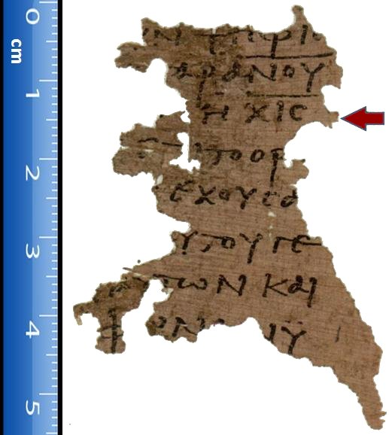
Papyrus 115

The Whore of Babylon prophecy as described in Revelation 17 and 18 could be pertinent for today.
Sign of the times? No? Then we must ask why does the Whore wear purple and red, and ride a red Beast and why is her name branded on her forehead? Might this be referring to the immoral side of America? The conclusion of many academics is that this is indeed the case.
There I saw a woman sitting on a scarlet beast that was covered with blasphemous names and had seven heads and ten horns. The woman was dressed in purple and scarlet, and was glittering with gold, precious stones and pearls. She held a golden cup in her hand, filled with abominable things and the filth of her adulteries. The name written on her forehead was a mystery: Babylon the great, the mother of prostitutes and of the abominations of the earth. I saw that the woman was drunk with the blood of God’s holy people, the blood of those who bore testimony to Jesus (Rev. 17:1-6, NIV).
Some even consider the Statue of Liberty in America as a ‘Trojan Horse’… a harmless-looking symbol of alleged liberty, but secretly, (to those who understand its true meaning) representing the harlot as spoken of within the Book of Revelation.
Rightly or wrongly, this idea may have come about due to the fact that most of those connected with the statue and the early American state, were Freemasons.
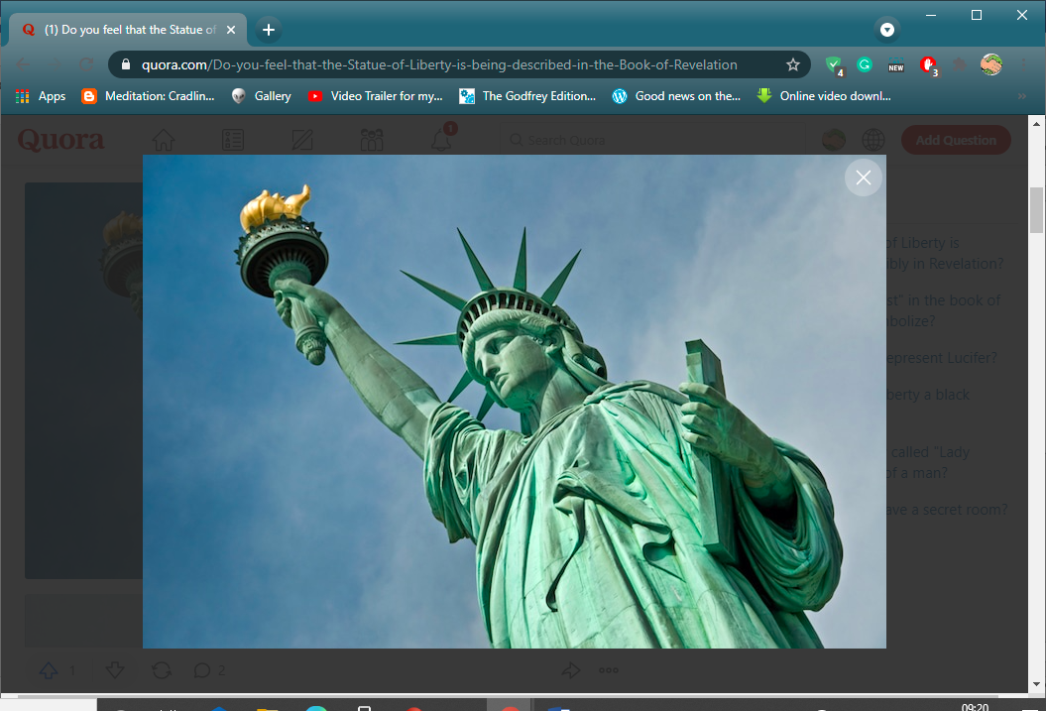
The Bible transcends time and is written to be interpreted throughout the different ages.
Preceding the King James Version of the Bible by 51 years, the language of the Geneva Bible was more forceful and vigorous, yet most readers of those times strongly preferred this version to the Great Bible.
Shakespeare may have even contributed to the King James translation; the idea that he played a part in creating the King James Bible looks quite believable.
Consider Psalm 46. If you count 46 words from the beginning of Psalm 46 and 46 words from the ending of the psalm, (not counting the “Selah’s”) you arrive at these two words: “shake” and “spear.” Try it.
It just so happens that Shakespeare would have been 46 years old in 1610, when scholars were finalizing the translations for publication the following year. So, was this the translators’ birthday tribute to Shakespeare in April 1610? Did he perhaps insert a disguised autograph into Psalm 46? Given Shakespeare’s connections at court with both Queen Elizabeth and King James, and given King James’s assemblage of a committee of over 50 known scholars, writers, and translators to work on the text, King James could easily have invited this wordsmith to contribute his expertise, perhaps proof-read and even edit, fine-tune, (shall we say) the translations.
Unlike some of those scholars who have gone before, we are not tweaking or changing anything, merely reading between the lines.
With that in mind, here are some interpretations appropriate for today.
Matthew 24:6 “Ye shall hear of wars and rumours of wars – see that ye be not troubled.”
= War on our minds, on our lives – tainting the way we live and think… the ‘new normal’ – social ‘reset’?
How about My House of Many Mansions? that is a paraphrase of…
John 14:2 which actually says “In my Father's house there are many mansions.”; but let’s take a step back here, what did that actually mean?
Most people consider a “mansion” as a giant home, having everything we ever want or need. Ideally, it would be a place of ultimate contentment and fulfilment.
But how can we be sure that it isn’t an allegory referring to dimensions? – in other words, there’s plenty of room for everyone in heaven.
In our everyday lives, we experience three spatial dimensions, and a fourth dimension of time.
How could there be more? Quite easily, and this heaven maybe all around us, unseen, undetectable, parallel worlds which some scientists suspect exist in different atomic/molecular frequencies to that of our material plain.
Centuries ago, they had to use a term of reference that people understood.
Genesis 2:16–17 And the Lord God commanded the man, saying, of every tree of the garden thou mayest freely eat: But of the tree of the knowledge of good and evil, thou shalt not eat of it: for in the day that thou eatest thereof thou shalt surely die.
Gene editing fits the bill well.
Gene editing involves changing a single DNA letter, or base, in a gene; but altering DNA in the human germ line - embryos, eggs, sperm or the cells that give rise to them, would create changes that could be passed on to future generations.
But it doesn’t stop there, oh no; the Covid Vaccines that millions of people are so keen to have could be altering their DNA… and THAT’S OFFICIAL!
Synthetic RNA in ‘Covid vaccines’ is changing human DNA: “New discovery shows human cells can write RNA sequences into DNA” … reports ScienceDaily.
“Date: June 11, 2021
Source: Thomas Jefferson University
Summary: In a discovery that challenges long-held dogma in biology, researchers show that mammalian cells can convert RNA sequences back into DNA, a feat more common in viruses than eukaryotic cells.”
We should be incredibly alarmed by these findings.
We should also be asking ourselves who or what is behind this?
As if we didn’t know.
The answer no longer requires a quantum leap of imagination; the term ‘conspiracy theory’ now becomes conspiracy fact!
This design hints of an invisible, spiritual evil!
It could be argued that we have always had these malevolent figures in our midst, working against all that is good; and this is true, but never in the course of human history have such madmen had the kind of technology as they have at their disposal today.
With what we have now – the human species could easily be wiped out – or made more compliant/manageable through genetic tinkering and mind control!
We can see the scenario already before us.
Isaiah 3:5 suggests - the people will oppress one another, man against man, neighbor against neighbor; the young will rise up against the old, and the base against the honourable.
Ritual humiliation, shaming episodes for 'non-compliance' - a nation of snitches?
Jeramiah 32:35 And they have built the exalted places of Baal, (today, some say this equates with the United States?) which are in the valley of the son of Hinnom, so that they may initiate their sons and daughters into Molech, (an owl effigy that is supposedly still worshipped by the *Illuminati) though it did not enter into my heart, that they should do this abomination, and so lead Judah into sin.
And incredibly, this kind of thing is still going on.
It is claimed that our world’s leader’s worship Satan and are willing servants of EVIL, but many are confined to calling them criminals. They who clearly lack kindness, compassion and empathy are controlled by Satan, the god of this world (2nd Corinthians 4:4).
Satan controls these men and women through the occult (i.e., "hidden" organizations). Jesus said, "in secret have I done nothing" (John 18:20), because He had nothing to hide.
Why the secrecy then from our nation's top leaders? We have examined numerous proofs that "the Skull and Bones Society is of the Devil.
High level, secret Freemasonry is of the Devil”.
As joint authors of this book, we were fortunate enough to have had the opportunity to examine shocking undercover footage of such a get-together; the type of genuine video Joe public rarely, (if ever) gets to see; and believe us when we say, what we saw was very occultist in nature.
In addition, it is hardly a secret how nearly 2,000 carefully selected government officials, corporate tycoons and other luminaries—men with power to shape the future—assemble privately every July in a redwood forest about 65 miles north of San Francisco.
The meeting includes a sombre ritual that features a Druidic burning of an effigy on the alter, chants from a robed chorus, and wild drinking and promiscuity. Richard Nixon once famously described the gathering as “the most faggy, Goddamned thing you could ever imagine.”
The bizarre Pagan ritual of the Bohemian Grove—the Cremation of Care ceremony, (just ‘Google’ Bohemian Grove to confirm, one of the few corroborated narratives that the ‘Fact Checkers’ and Internet police can’t completely censor) is practiced by its members, (all men) including former presidents George Bush, Bill Clinton, Ronald Reagan, Richard M. Nixon, Jimmy Carter; other prominent figures such as Walter Cronkite, Alan Greenspan, Colin Powell and Henry Kissinger to name but a few, were also ‘Grove’ associates.
Even Edward Teller, the Hungarian/American theoretical physicist known colloquially as "the father of the hydrogen bomb", was himself a ‘grover’!
Members of the Bohemian club who owned/own? that land, also included/include? bankers, scientists, doctors, and the heads of ‘big pharma’; those who pushed, (and are still pushing today) their poisons on the public using massive back room deals with governments and TV and radio to further their agendas.
Paedophiliac rituals by attendees at this sinister meeting, held every July, have also been reported.
It’s absolute madness, but our ostrich-like, (heads buried in the sand) denial about so many things in life that we don’t want to believe are true, allows this kind of thing, (certainly perverted, dare we say evil?) to go on largely unchecked.
Elites at the highest level are all in on this; those running the world each go to these rituals; either at the BG itself or a similar venue elsewhere.
But the Devil’s Advocate would argue… that’s just a different set of values; ‘rituals’ you say but isn’t everything in life a ritual? Public schooling is a ritual… going to work is a ritual, even religion… praying in a church is a ritual; we all engage in rituals, so maybe what they do at the Bohemian Grove isn’t so bad after all; oh, but it is!
This kind of thing is the last and ultimate enticement of Satan… his divine temptation - the rhetoric of hell.
A warning of things-to-come. A world where science, medicine and technology are perverted, where freedom is just an illusion; where each of us are little more than a number assigned to us at birth; free, but only to do as our elite masters say… free to behave as they command, and free to think how they want us to think.
Naturally, any victims of the greatest con-trick ever perpetrated by the devil, convincing the world that both he and God don’t exist, will simply ignore what is written here out of disbelief.
Here’s another good one, about not judging others – something that we all do from time-to-time.
Matthew 7:3 Thou hypocrite, first cast out the beam out of thine own eye; and then shalt thou see clearly to cast out the mote out of thy brother's eye; cast those scales from thine eyes.
And it is wondered how the ruling elite see us?
Then there is seeing through a glass darkly.
1 Corinthians 13:12
King James Version
12 For now we see through a glass, darkly; but then face to face: now I know in part; but then shall I know even as also I am known.
To see “through a glass” - a mirror - “darkly” is to have an obscure or imperfect vision of reality. The expression comes from the writings of the Apostle Paul; he explains that we do not now see clearly, but at the end of time, we will do so.
Modern day take: We must see that science is playing at being God; for example, those who gave us the SARS-COV-2 virus, who then insisted on compulsory ‘lockdowns’ which dramatically worsened the catastrophe, and who then pressed for global immunisation of the world’s population as the only way to escape further disaster, plunging humanity into an uncertain future; this is the take home message; the deniers who ask for proof will get it, in time.
Filled with uncertainty and insecurity, we are now all inmates of an open prison, (with some time-off for good behaviour) and always will be, whenever they want to lock us up and eventually let us out again.
They call it ‘lockdown’ - the original dictionary definition of which is “the confinement of prisoners to their cells for a prolonged period of time, usually as a security measure following a disturbance; the point at which such confinement begins. Also, in the context of a psychiatric hospital or other secure unit.”
More like ‘lock up’ we would say.
As these words are written, we all need a “reasonable excuse” for leaving home under the government’s Coronavirus regulations. Physical limitation bound by law is one thing, but enslavement of the mind isn’t so easy for our authoritarian state to enforce; this can be overcome; whether the situation is ‘pandemic or post ‘pandemic’; existent virus or not, we must break free of our mental shackles.
Corinthians 15:34 Awake to righteous and sin not, for we are all children of light and children of the day; therefore, let us not sleep as do the others, but let us watch and be sober; it is high time to awake out of sleep.
= waking up to what is going on and stop living in denial. This could easily be applied to the times we are currently living through; a clue for which can be found in the mysterious Georgia Guidestones: Google it to find out more; we must be on our guard for the development of a one world government and any depopulation agenda – [which already seems to be starting].
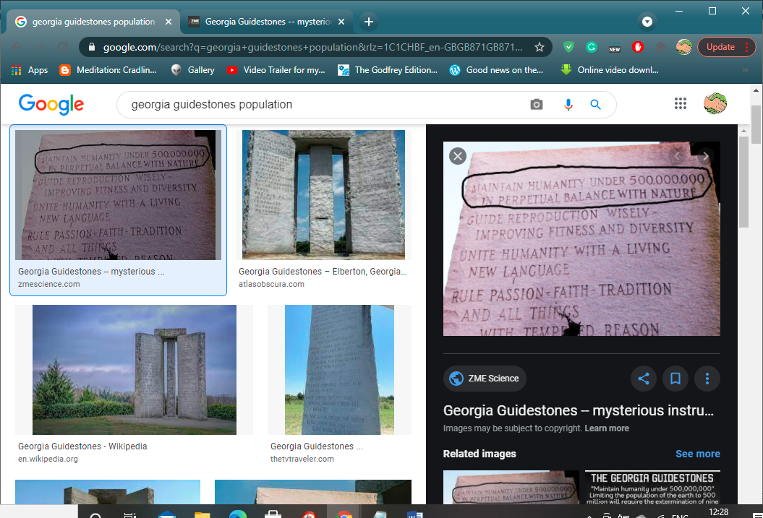
For now, is our salvation nearer than when we believed; the night is far spent, the day is at hand, let us therefore cast off the works of darkness and let us put on the armour of light.
Wherefore take unto you the whole armour of God that ye may be able to withstand in the evil day; having done all to stand, cast away from you all your transgressions: Whereby ye have transgressed and make you a new heart and a new spirit.
Is resistance futile? should we all comply or die?
Of course, it will be said that any hint of accusation is just left-wing nonsense… it's part of bringing about a "New World Order" sniggers all round. Fact-check, nothing proven, next please.
But not so fast - we get the feeling, that with a constant cycle of bad news, the public are being softened up, desensitised.
Humans are notoriously bad at assessing risk, that’s why instead of just blindly playing follow the leader, becoming subtly programmed by ‘telly’ programmes, mimicking what others do and say in the media, each of us must use our own logic before we automatically accept that this is how life is… the way of the modern world… the ‘new normal’.
There’s none so blind as those who will not see; maybe that’s because they have been blinkered to see only the road ahead leading to a life which has been mapped out for them.
Corinthians 1:20 says “Where is the wise person? Where is the teacher of the law? Where is the philosopher of this age? Has not God made foolish the wisdom of the world?”
Either side of so-called left wing/right wing ideology is often where it’s at, in terms of creative thinking, original discoveries, new information, alternative routes.
Intelligent people have inquisitive minds; they ask questions, and do not simply believe what they are told – or blindly obey orders… or gullibly follow the proverbial dangling carrot, tempting them to walk forward evermore.
That’s roughly about half of us.
But there are always those who are easily led; and big player attempts at halting the spread of unauthorized information/manipulating social attitudes/behaviour in order to produce desired characteristics in a target population is now beginning to take effect.
Whether that is through the use of government educational programmes, media persuasion, or even enlisting the help of approved activist groups (the Pharisees of our day), social engineering is quite contrary to the original intentions of God.
In Bible terms, it is called following people instead of the Lord.
Under the guise of ‘political correctness’, traditional values and beliefs are no longer taught, and in fact, they are persuaded against in the classroom.
History is being revised.
That marriage is not only between a man and women, but marriage is just as likely to be couples of the same sex; and how contempt must be shown for anyone who thinks otherwise… and gender fluidity, being *non-binary is somehow fashionable - the new normal… more like the new Abnormal!
*Non-binary or genderqueer is an umbrella term for gender identities that are neither male nor female‍—‌identities that are outside the gender binary.
Leviticus 20:13 If a man lies with a male as with a woman, both of them have committed an abomination.
Yet confusingly, in Genesis 1:27, it states “So God created humankind in his image, in the image of God he created them; male and female he created them”.
He created male and female in God’s image – both sexes!
People have admitted that they rely on technology too much and actually believe that it dehumanizes them. One study found that 35% of people who own cell phones report checking their devices more than 50 times a day!
Technology has pushed us to lose our ability to communicate with each other face-to-face; many can’t enjoy a meal without checking their phones.
Instead, they choose to disregard things like family life, mixing with friends; they would rather scroll through Instagram or Facebook for hours on end… and speak using computer jargon and other clinically disconnected terminology.
Prove us wrong, but we think as a result, many have lost the capacity to show kindness and empathy toward one another, becoming shallow and uncaring.
Basically, people are becoming less human and are living in a virtual reality.
We believe that this dehumanization is planned and was talked about in the Bible.
Corinthians 6:19-20 says you are not your own, for you were bought with a price. So, glorify God in your body.
Instead of being led down the right path, and being dictated to, constantly reminded it’s the right thing to do, our social duty to obey, we need to choose the path that is correct for us, which isn’t always located on the right-hand side!
We are repeatedly instructed how the Left-Hand Path is equated with malicious dark forces, while the Right-Hand Path is the path to Christian wisdom.
Nowt but trouble down one, enlightenment down the other; so, everyone is herded along the right path – while the shepherd, (our controllers) doubles-back and heads along the other route.
The question is – which is the path to the purest, most complete knowledge?
Revelation 13:18 This calls for wisdom. Whoever is intelligent can figure out the meaning of the number of the beast, because the number stands for the name of someone. Its number is 666.
Revelation doesn't say it is insanity to try and figure out who it is. It says it takes wisdom and intelligence to work it out.
Revelation 13:16-18, "And he causeth all, both small and great, rich or poor, free and bond, to receive the mark. . . the Revelation mark in their right hand, or in their foreheads: And that no man might buy or sell, save he that had the mark, or the name of the beast, or the number of his name. Here is wisdom. Let him that hath understanding count the number of the beast: for it is the number of a man; and his number is Six hundred threescore and six."
How about a number of men, (plural) and their number is 666?
Or is it humanity’s number?
Problem is, do we conform to or resist the rules of those who govern us?
Romans 13:1-7 Suggests that all of us must obey the government rules, never mind our birth right of freedom; that our governors are God’s representatives here on earth.
But something within us questions, hey, these are only fat cats, privileged people who have wormed their way to the top through politics; note how it’s always the wealthy who rule over us? no poor person has ever become prime minister or president.
Come on now, they are not ‘Lords’ in the truest sense… there is only one ‘Lord’ – the Lord God Almighty.
Lots of them are lords of the land certainly – landed gentry, and that’s about it.
So, just why should we allow government rules and regulations to become tightly enmeshed in and limit our lives? why should we obey them – when so many at the top clearly live life according to their own dictum? 'Do what thou wilt’.
They preach one thing and are often caught doing the complete opposite.
We see them on special occasions attending a Christian church – and indeed they seem to be praying, but to which God – ours or theirs?
It is reckoned that their secret god is Baphomet, who is partly hermaphrodite (e.g. half-human and half-animal, male and female, good and evil, etc.).

Note on this image, how on the Baphomet's stomach are two serpents entwined around a staff… the same sign that the medical profession employ.
Yes, they go through the motions when on public display, even though it has been proven that the majority are inner core Freemasons, (high level, not your 1st, 2nd and 3rd level nonsense) who are claimed to be a 'Occultic' Brotherhood with royalty, many leading politicians, judges, bankers, heads of police, doctors and even clergymen in its ranks, but it is supposed however, that they may bat for both sides – in more senses than one.
Concerning Freemasonry and their Pledge of Fidelity, it reads: ‘the secrets of nature and the principles of intellectual truth were then unveiled to your view.
To your mind, thus modelled by virtue, science and nature present one great and useful lesson more.
She prepares you, by contemplation, for the closing hour of existence, and when, by means of contemplation, she has conducted you through the intricate windings of this mortal life, she finally instructs you to die.’ End quote.
Note the consistent references to a female deity? (one could hardly miss them!)
Remember, here we are talking about members of the highest Masonic order, which takes us to what is often called the ‘Illuminati’ level, these people may covertly revere the sacred feminine side of Baphomet.
This devil is among the many hellions cast out of heaven for one reason or another and said to be still roaming the earth in spirit form.
With something of such magnitude, the exact answer as to who or what their god might be, is veiled in mystery; though several top occult researchers have confirmed the hermaphrodite aspect of this, the god of our mentors… a creature that has both male and female sex organs or other sexual characteristics.
If correct, is the REAL reason why we are recently seeing so much blurring of sexual boundaries in media presentations, far deeper and darker than is obvious?
Is there something more than just political correctness behind this big push for sexual equality and for the gender identity-based cultures?

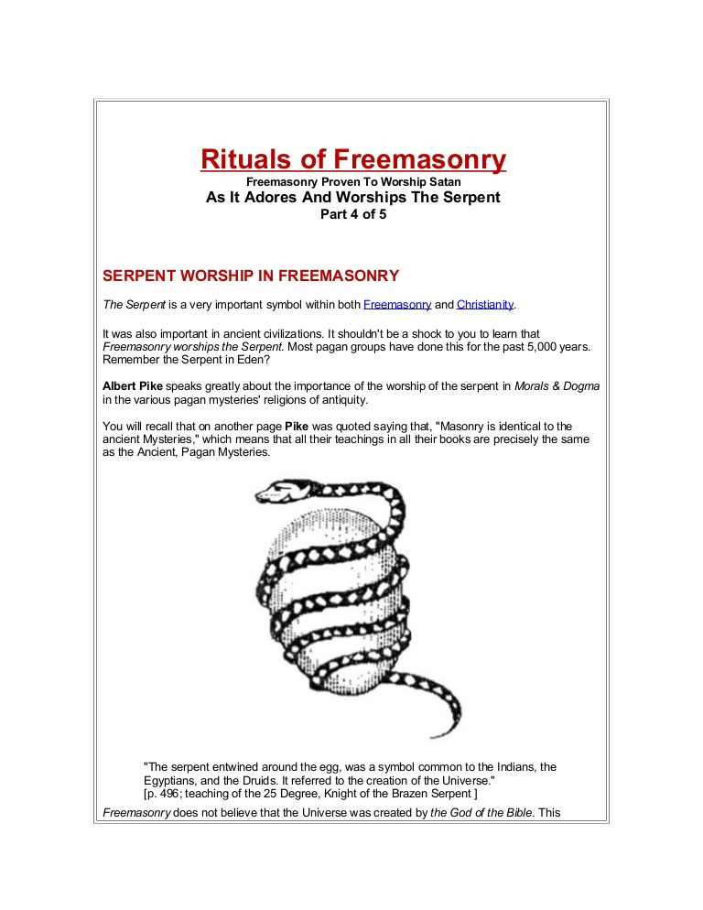
This seems to be all out war – a war for our minds… and the rebel within says prepare for visible resistance!
As the old saying goes – its better the devil you know – and we must certainly know who, or what, this d-evil is by now.
Normally, most of us would avoid people, cults and forces such as that… like the plague; yet we fear that the human population is gradually being sucked into a dark agenda without them realizing what is happening.
A programme on a year or so ago, with TV hypnotist Paul McKenna just about sums things up. He would hypnotise a few people on stage and make them look like idiots, then at the end of every show he would attempt to hypnotise the whole audience, but out of the few hundred audience members, there would always be a couple that he couldn't put under.
Kind of’ reminds us of what's happening today – but now its Mass Hypnosis via the media; and yet, try telling someone they are under their spell and you are talking to a brick wall.
If a frog is suddenly put into a pot of boiling water, it will jump out and save itself from impending death; but if the frog is put in tepid water which is then brought to a boil slowly, it will not perceive the danger and will be cooked to death.
It is feared that like the frog in this metaphor, many in the world are slowly being cooked alive, thanks to attacks on their knowledge and liberty, that arise gradually rather than suddenly.
Matthew 24:3-8 NKJV
End Times Signs… The Culling of Humanity Through Disease and War?
3 Now as He sat on the Mount of Olives, the disciples came to Him privately, saying, “Tell us, when will these things be? And what will be the sign of Your coming, and of the end of the age?”
4 And Jesus answered and said to them: “Take heed that no one deceives you. 5 For many will come in My name, saying, ‘I am the Christ,’ and will deceive many. 6 And you will hear of wars and rumors of wars. See that you are not troubled; for all these things must come to pass, but the end is not yet. 7 For nation will rise against nation, and kingdom against kingdom. And there will be famines, pestilences, and earthquakes in various places. 8 All these are the beginning of sorrows.
Matthew 24:3-8 Beware that no one leads you astray.
Could the current coronavirus pandemic be a sign of the Second Coming of Christ? We’re not certain, but it could be evidence of the third sign on Jesus’ list, pestilence. The word pestilence is variously defined in dictionaries as “a fatal epidemic disease”, “a contagion or infectious epidemic that is virulent and devastating.”; and that describes perfectly what’s happening in the world right now.
Are we being led astray?
Whether its natural, (for example - a strain of flu) or a ‘manmade bioweapon’ as some have claimed, we’ve heard it said by quite a few medical professionals, that the current gene therapies being injected into the arms of millions are actually causing the Covid-19 virus to mutate.
Mutation is its own survival mechanism… its means of escape.
This will eventually lead to less efficacious vaccines.
Also, there is the scamdemic school of thought, which says the Covid-19 virus didn’t even exist initially.
The whole thing was “planned by a group of elites who are dictating to governments globally”.
Covid-19 is just the flu re-branded; and that life after COVID-19 could see a world with a depleted population, along with “harsh tyrannical rules governed by a centralised totalitarian state”.
Already, thousands of deaths and cases of health compromised worldwide have been linked to adverse effects from Covid-19 vaccines.
This is particularly prevalent amongst the frail and elderly.
Let us assume that figure is in the low thousands, (and bearing in mind they are only the ones that get reported) we must remember that those lives cut short are from millions, upon millions of vaccinations having been administered; so, depopulation, starting with the old, (maybe to save states having to pay out on pensions and care?) surely, that is the outer bounds of possibility?
A reworking on this wacky, rank outsider, fringe theory of-an-idea suggests…
…the gene-instructing therapies being pumped into the shoulders of us human guinea pigs, (and being the veritable walking incubators that we are) our systems are creating new variants of the flu.
And hundreds upon hundreds of recipients of this experimental shot have died.
A handful of maverick doctors have spoken out on how this will shorten peoples’ lives – and in some cases, end them completely!
Some state health problems in receivers start manifesting 4 weeks to a year out from having the shot. We have read others warning how "people will drop like flies"; and another doctor claiming people have a 3-year life expectancy after getting the vax due to their immune system having been dramatically weakened by it!
We’re not claiming those are facts - just saying.
It has to be wondered, what’s the great panic into getting the whole world jabbed? even ‘fact-checkers’ admit that the “survival rate” is somewhere between 99% and 99.5%, so the chances of the unvaccinated dying from this alleged virus is akin to being struck by lightning.
Why are we in such a rush to form ranks at the vaccination centres, and offer ourselves up?
It saddens us to see so many people giving in to what is a kind of emotional blackmail, using our fear of mortality as bait.
Now here’s a strange fact, a REAL bona fide, provable, OFFICIAL fact that might link into such off the Richter scale ideas.
New peer-reviewed studies suggest there may be terrifying reasons side effects such as heart inflammation, VITT, (Vaccine induced Thrombosis and Thrombocytopenia) and other serious issues may occur in those who have been vaccinated.
The coronavirus spike from certain mRNA COVID-19 shots does sometimes, unexpectedly enter the bloodstream, and a subset of people may face a variety of adverse side-effects.
The risk of blood clots associated with the AstraZeneca vaccine are now well known; ‘rare’ says the literature, but from our research not THAT rare.
And the drugs don’t work, (not as it says on the tin) anyway, because it is reported that hundreds of people who have been given two doses of a synthetic coronavirus concoction have become infected by the virus every day.
Surely, it couldn’t be the shot itself that’s the problem – nah, that’s just too easy!
No matter how many accredited figures say that they aren’t at all confident about the mid/long-term effects of the Covid shot, it appears that everyone still wants it; can’t get enough of the jabs some people… almost to the point of addiction.
According to ‘conspiracy theorists’, whichever theory one chooses… Covid-19 is/was a carefully engineered hoax of epic proportions - a plandemic; complete with the war-like government guidance, its £1.6 billion spending on advertising, trade-marks, PR campaigns and support such as… ‘social distancing’, the mandatory wearing of masks, (‘face nappies’, ‘muzzles’ or even ‘facial panty liners of subjugation and shame’ as we have heard them called variously) elbow bumps, (informal greeting where two people touch elbows) clapping for the NHS and carers at 7pm, ‘Protect the NHS’.
Doing the ‘elbow bump’
Aggressive advertising campaigns ramping up pressure to get the jab; ‘buzz’ slogans/pieces of text, terms repeated ad nauseum in the media internationally, (rather like a mantra… the guiding mantra of those in power?) emotive memes/catchphrases such as… ‘act like you’ve got the virus’, ‘do your bit’, ‘Long Covid’, ‘isolate’, ‘self-isolate’, ‘variants’, ‘stay at home’, ‘stay local’, ‘don’t blow it’, ‘roll up your sleeves and do your part’, ‘Freedom Day’, ‘If You Want A Life – Get A Jab’, ‘Vaccinated Only Music Concert’, ‘post-Covid life’, ‘self-isolate’, ‘refuseniks’, ‘covidiots’, ‘Eat Out to Help Out’, ‘Rediscover Summer’, ‘We Are in This Together’, ‘The Power of ‘X’’, ‘Nobody is Safe until Everyone is Safe’, ‘anti-vaxxers’, ‘vaxxer’, or ‘vaxxers’, or ‘vaxxed’,’One Collective Voice’, ‘the new normal’, ‘the great global reset’, (a rebranding of the New World Order?) ‘Vaccines are the ticket back to pre-pandemic normal’, ‘Hands, Face, Space’,‘VerifyStudents’, (‘Immunitrax’ - digital vaccine passports for students) ‘Green Passport’, ‘vaccine certificate’, ‘vaccines versus variants’, ‘Jab and Go’, ‘Have Your Jab and You Can Hug a Loved One, ‘Vaccine Buddy’, ‘Covid Marshals’, ‘Asymptomatic’, ‘Less Risk More Freedom’, ‘Frontline’, ’Surge Testing’, ‘Joints For Jabs’ (in Washington State – Google it, were not kidding) ‘Free Childcare For Vaccinations’, ‘Free $5,000 Scholarships For Vaccinated American Students’, ‘Covid Restrictions’, ‘Let’s Take This Next Step Together’.
‘Super Spreaders’, ‘Novel Coronavirus’, ‘PCR Test’, ‘Rapid Lateral Flow test’, ‘Vaccine Hesitancy’, ‘Let’s Tackle Covid’, ‘wash your hands while singing happy birthday’, Covid Passports, which became the EU Digital Covid Certificate – now, ‘Digital Wallets’, (I.D. cards by another name), ‘Digital Compliance’, ‘Social Credit’ database, ‘Build Back Better’, ‘Corporate Screening’, ‘Fear Porn’, ‘No Jab – No Job’, (compulsory Covid vaccinations for carers), ‘No Jab, No Fly’, ‘Jabs For Jobs’, ‘It’s Up to You’, ‘Adaptive Learning’, ‘Gain of Function’, ‘Biosecurity’, ‘Vaccine Bonus’
‘Lab-Leak Theory’, ‘Grab A Jab’ (at your pop-up vaccination centre).
*‘Cytokine Storm’, ‘Control The Virus’, ‘Follow The Science’, ‘We are all in this Together’, ‘Behavioural Insight Team’ (formerly the ‘Behavioural Change Unit’), ‘Data Not Dates’, ‘Let’s Not Go Back’, ‘React 1’ (the Real-time Assessment of Community Transmission (REACT) Study, ‘Can you look them in the eyes and tell them you’re helping by staying at home?', ‘Vaccine Sommeliers’, ‘v-safe’ (the Covid-19 Pregnancy Registry - after vaccination health checker surveillance team), ‘Jab in Each Arm Drive’, [Vaccination] ‘Tent of Hope’, (or Dope as we joked) ‘Be Free From Fear’, ‘Terminus Date’, ‘Stand & Shop Apart’, ‘Vaccine Shy’, ‘Live With The Virus’, ‘Herd Immunity’, ‘Vaccine Deployment Programme’, ‘Flatten The Curve’, ‘Covid Digital Staff Passport’, ‘The Human Crisis’, ‘Public Health Emergency’, ‘Roadmap To Freedom’, ‘Vaccine Rollout’, ‘Vaccine Status Matters’, ‘Covid Control Rules’ – (for schools) ‘Covid-19 Initiative’, ‘Covid Isolation Rules’, ‘Vaccine Deployment Strategy’, ‘Emergency Mortuary Units’ for ‘Mass Casualty Events’? ‘The Vaccine Divide’, ‘Group Think’, ‘Track and Trace’, which after public concern was quickly changed to ‘Test and Trace’, (the failed system and its unimaginable £37 billion cost) ‘Father, Son and Holy Spirit’, (only joking there, but note, how they do love their trifectas) and ‘National Thank You Day’, were/are just psychological, controlling ‘spin’…
…all part of the labyrinth that is being created around us to keep their cunning ruse going for as long as they can get away with it.
*During a cytokine storm, various inflammatory cytokines are produced at a much higher rate than normal. This overproduction of cytokines causes positive feedback on other immune cells to occur, which allows for more immune cells to be recruited to the site of injury that can lead to organ damage.
Yes, it looks as if the brainwashing gurus have been brought in to try and change the way we think; but not everything is going to plan; following some straw polls made during our research for this book, more and more, people are saying that the conspiracy theorists were right all along; not about everything it’s true, but certainly something is up, and big-time!
Most never were ‘conspiracy theorists’ – only very informed people!
Then, (as if all that propagandic spiel wasn’t enough) we have ‘the Tony Blair Institute for Global Change’ – ‘directly supporting leaders in their on-the-ground fight against Covid-19’.
[As an illustration of how politicians are all peeing in the same pandemic pot, Nigel Farage, former politician who served as Leader of the UK Independence Party from 2006 to 2009 and 2010 to 2016 and as Leader of the Brexit Party from 2019 to 2021 is quoted in The New European January, 2021 as saying that Tony Blair should lead the UK's vaccination programme, adding the former Labour prime minister "commands respect" and is "seriously bright"]
Why though?
For what reason?
Anyone would think that Old Nick himself has taken over or something, using Covid-19 as a cover for mass genocide – a gradual culling of the human population!
Ludicrous – isn’t it?
Or maybe, just maybe, it’s a case of being too blind to see what’s in front of one’s nose.
Have the many been docile, foolish, and led humanity into a totalitarian nightmare?
Maybe time will tell; trouble is, these days, we have a state/government-run Internet, so how would we ever know that this whole Covid issue wasn’t just a monumental trick?
If true, by the time the sheeple wake up and try to change things, it will be too late.
Believest Thou This?
We find it highly suspect indeed, how numerous governments and nongovernmental organizations across the globe have asked Google to censor content. Records show that ‘in 2012, Google ruled in favour of more than half the requests they received via court orders and phone calls.’
‘Google and its subsidiary companies, such as YouTube, have *removed or omitted information from its services in order to comply with company policies, legal demands, and government censorship laws.’
*The sort of keywords that the algorithms look for: COVID-19, Covid hoax, Covid myths, Covid deaths, Covid side effects, David Icke, freedom march, antivax, adverse vaccine reaction, scam, scamdemic, plandemic, conspiracy beliefs, health, behavior, coronavirus, pandemic, coronavirus mentality.
‘YouTube's product chief said that the Google-owned video site has removed thousands of COVID-19 videos.’
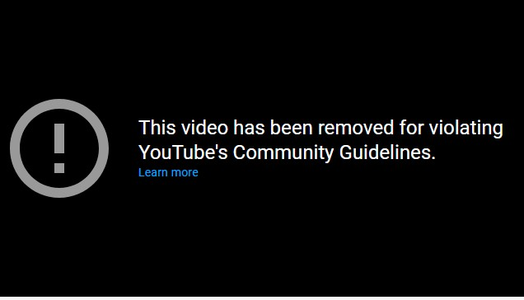
Gone but not forgotten: We wanted to show you this – where retired police constable Mark Sexton made a criminal complaint to Warwickshire police against double-standard merchants Boris Johnson, Matt Hancock, Patrick Vallance, Chris Whitty, Dominic Raab, Michael Gove and Nadhim Zadhawi. A complaint which included the shocking statistics on adverse reactions and deaths due to the Covid-19 vaccines found in the MHRA Yellow Card data; but guess what? YouTube ‘kindly’ removed it. Thanks to The Daily Expose for these details. Providentially The Conservative Woman website made a copy of this first, and the video, along with the whole story, can be viewed here.
https://www.conservativewoman.co.uk/this-retired-police-constable-standing-up-to-the-government-vaccine-fanatics-is-a-hero/
But we don’t hold out much hope of this complaint going any further than a wastepaper bin, because, when necessary, the state can subvert the legal system; and anyway, by now most readers should be fully aware of its diabolical allegiances.
Many have also just changed their ‘terms of service’… to ban all sorts of free speech.
‘This online publication has been corrected’ is a notice we come across quite frequently as well regarding C-19; but ‘corrected’ from what?
Social media companies including YouTube, Vimeo and Facebook are removing viral conspiracy theory videos because of their claims regarding the coronavirus pandemic.
When videos began to disappear from YouTube, supporters bombarded Twitter with claims that they were being unfairly censored.
“This period is a dreamlike situation for any authoritarian government,” says RSF’s [Reporters Sans Frontiers] Asia-Pacific director. “They can pretend to protect their citizens from ‘fake news’ while being the only authority that can precisely decide what is true or what is false. In this regard, the coronavirus crisis is a formidable pretext to impose censorship.”
Twitter have recently removed more than 70,000 accounts, mainly the type that promoted Covid-19 ‘conspiracy theories’. The suspensions were carried out over the weekend and applied to posts with “the potential to lead to offline harm”.
Propaganda hates debate.
The Internet and social media are now so co-ordinated in their partiality that it’s hard to find the REAL facts behind all of this, without a lot of underground 'digging'; maybe answering the question of why so many blindly trust that this jab is for their safety?
By the way, in America the federal government has decided to pay hospitals more for treating COVID-19 patients. This fact comes from Kaiser Health News, which partners with PolitiFact on health fact-checking, an editorially independent program of the foundation.
Kaiser estimated the average Medicare payment at $13,297 for a less severe hospitalization and $40,218 for hospitalization in which a patient is treated with a ventilator for at least 96 hours; a nice financial incentive there – no?
Thinking in terms of The Book of Revelation again, and it has been said that the mandatory wearing of face masks, (those badges of affiliation) is a precursor to the Mark of the Beast… a social conditioning that is in itself, part of an Occult ritual.
Their over-arching plan is that of mental manipulation; enabling those who are behind this… be that physical and/or spiritual, to measure how effectual they are at controlling the population.
This observation is not far-fetched.
As we have seen, censorship is in full force – and pray what is the symbol for censorship? A masked human face... the mouth covered.
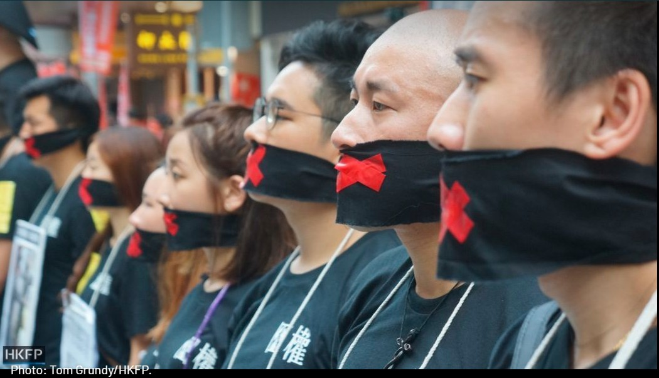
Anyone who attempts to get this information out, no matter who the whistle-blowers are… care home assistants, even doctors and virologists, are silenced and many of their channels are being removed from Facebook, Twitter, YouTube and censored from other, similar social media platforms.
About the mask.
Countless words are similar to others, that is true, but in the context of this book, we must remember that ‘Mask’ is just one letter from ‘Mark’.
But before anyone gets all hot under the collar about this issue, the Bible also denounces mask-wearing, in the sense of hypocrisy.
Even if you don’t see it straight away, the Bible suggests do not worry, the dark curtain will be lifted, and the Antichrist will be exposed; then we will all know for sure.
Harking back to Revelation 14: 9, it is worth pointing out another real eye-opener concerning this chapter; nearly all Bibles’ we have examined, (such as the Christian Standard Bible, New Living Translation, New American Standard Bible, English Standard Version and the New International Version) say “receive the mark ‘on’ his hand”, but in one, the King James Version, in both Rev 13:16
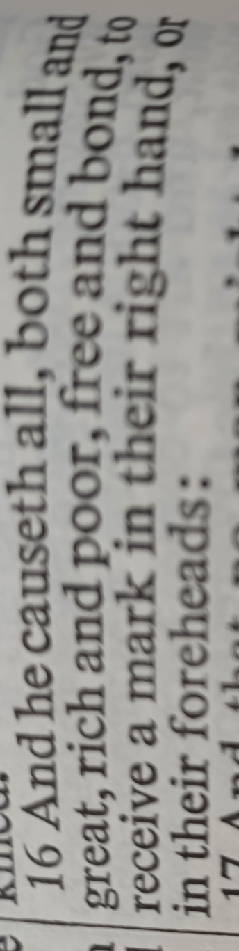
and 14: 9, it says “and the third angel followed them, saying with a loud voice, if any man worship the beast and his image, and receive his mark in his forehead, or in his hand.”
Remember the specific wording “IN his hand”… not ‘on’ it.
This parody of ‘in’ to ‘on’ could be most significant, and here’s why. Around 4,000 people in Sweden have already been 'chipped' and some organisations say implants could be on their way to the UK. Carrying credit cards, oyster cards - even your house keys or ID - will soon become a thing of the past.
Digital tracking will help ensure that billions of people are immunized against the coronavirus.
“and one after the other, they held out a hand to an administrator who pushed a rice-grain sized RFID implant into the flesh between the thumb and forefinger.”
Radio-frequency identification uses electromagnetic fields to automatically identify and track tags attached to objects. An RFID system consists of a tiny radio transponder, a radio receiver and transmitter.
Then we have Bill Gates, The World Health Organization's biggest donor in all of this.
“First, we’ve got population,” he said during the talk organized by TED, a non-profit organization devoted to spreading ideas. “The world today has 6.8 billion people. That’s headed up to about nine billion. Now, if we do a really great job on new vaccines, health care, reproductive health services, we could lower that by, perhaps, 10 or 15 percent. But there, we see an increase of about 1.3.”
However, Gates was not suggesting the global population should be reduced using vaccines… no, no, Fact-Checkers claim he is actually stating that improving public health using vaccinations can reduce unsustainable population growth in the future.
Oh, that’s alright then, we were reading this out of context. Think about it.
As NBC News reports, his dad, William Gates Sr. worked on the board of Planned Parenthood prior to his death in September 2020.
Planned Parenthood are involved in abortion.
In their 2014 Annual Report, PPFA reported seeing over 2.5 million patients in over 4 million clinical visits and performing a total of nearly 9.5 million discrete services including 324,000 abortions!
Hmmm.
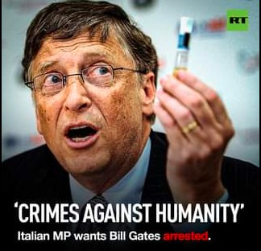
“Fact-checkers aim to get closer to the truth, but their biases can shroud the very truth they seek.” Quote from ‘The Psychology of Fact-Checking’ - a report by Stephen J. Ceci, Wendy M. Williams on October 25, 2020, published in the Scientific American.
And here’s another from our enri’ (Henry Kissinger see Bohemian Grove earlier) claiming to say “Depopulation should be the highest priority of foreign policy towards the third world, because the US economy will require large and increasing amounts of minerals from abroad, especially from less developed countries.”
When asked, Zebra Fact Check said we did not find an attribution for the whole quotation.
But when we broke the quotation into pieces, we found a big hunk in NSSM 200, also known as “Implications of Worldwide Population Growth For U.S. Security and Overseas Interests (THE KISSINGER REPORT).” NSSM stands for “National Security Study Memorandum.” The government document was published in 1974 and made public in 1980.

“Whatever may be done to guard against interruptions of supply and to develop domestic alternatives, the U.S. economy will require large and increasing amounts of minerals from abroad, especially from less developed countries.
That fact gives the U.S. enhanced interest in the political, economic, and social stability of the supplying countries. Wherever a lessening of population pressures through reduced birth rates can increase the prospects for such stability, population policy becomes relevant to resource supplies and to the economic interests of the United States.” [End]
Thanks, that clears things up (wink, wink).
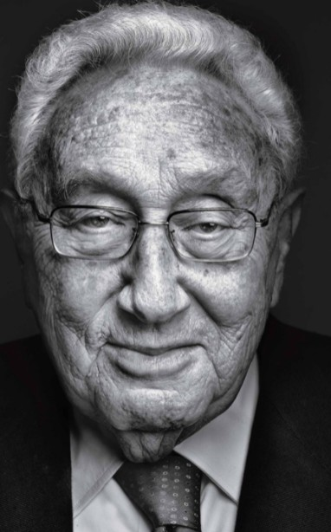
Look almost anywhere on the Internet and the first few pages will be the newly created fact check this and fact check that.
Ever wondered who these fact-checkers are? The ‘fact’ is many can be traced back to have government agency or associated ‘big pharma’ connections.
It is patently obvious that search engines have been flooded with a uniform propaganda, which is to get those ‘vaccine’ doses into us as fast as possible; and any critics of this are canned, character assassinated and ridiculed.
So, how is this vast cover up all being achieved?
Here is a clue that should leave you in no doubt.
It has come to our attention how, in the States, virtually every single major news station has a ‘big pharma’ CEO on their board in hugely well-paid jobs.
We assume that it’s much the same in the UK, and with many of the top brass at these outlets also having big share portfolios in pharmaceutical industries.
We are being socially programmed to reject any rhetoric against vaccines by these guys all singing from the same hymn sheet in their Covid-19 drive.
And that includes satellite channels; look through the news from around the world… hundreds are near-identical in their reports – similarly scripted, standardized with comparable terminology used.
Nearly every world leader is now basically calling for the same thing; unless they have a medical reason, every man, woman, and child on this planet is to be vaccinated by the end of 2022 to "defeat Covid".
Tony Blair has said it is "time to distinguish" between people who have and haven't had a coronavirus vaccine.
The former prime minister has warned it "makes no sense at all to treat those who have had vaccinations the same as those who haven't" - and said relaxing measures for those who have had both jabs will provide a powerful incentive.
In other words, a divided society is being created where the vaccinated masses are being taught to shun those who remain unvaccinated.
Yet in the Bible it clearly states…
“It is a sin to despise one's neighbour, but blessed is the one who is kind to the needy.”
It’s enough to make anyone wonder whether this is the work of a shadow government, run by a private cabal of wealthy, sinister individuals who exercise power behind the scenes, beyond the inspection of democratic institutions.
Are we witnessing the New World Order?
There are those who have warned scientists are playing grand creator in the re-shaping of human genetics…
…that what these white coats are doing is a follow-on from the father of genetics himself Josef Mengele, also known as the Angel of Death (German: Todesengel) was a German Schutzstaffel (SS) officer and physician during World War II.
Latest real news 2021: A male rat in China has given birth by Caesarean section after a 'vile' experiment that involved joining it to a female rat and transplanting a uterus.
Obscene, yes/no? and this kind of thing is going on behind closed doors, in some lab somewhere, as you read these very words.
On Genetic Engineering the Bible has this to say:
Corinthians 15:38: But God gives it a body as he has chosen, and to each kind of seed its own body.
We should ask ourselves, are these authorities, or those behind them, being unwittingly influenced by dark forces, (perhaps at a subconscious level) where their mischievous work requires the Back Engineering and defiling of God’s creations?
What kind of madness is responsible for such abominations? The command of impostors like the Archons, fallen angels, demons - or even Satan himself perhaps?
Is Satan even real? As a force of darkness – we would say yes, unquestionably.
Luke 10:18 refers to "Satan falling from heaven" and Matthew 25:41 mentions "the Devil and his angels", thrown into hell. All Synoptic Gospels identify Satan as the leader of demons.
Revelation 12:9
And the great dragon was thrown down, that ancient serpent, who is called the devil and Satan, the deceiver of the whole world—he was thrown down to the earth, and his angels were thrown down with him.
Clearly, much of the Internet is now deceptive – and it’s only going worse; unofficially, it is already being censored; we can confirm this; and the same goes for TV; although many may not realize it, television has largely become a state propaganda and social control tool.
Jeremiah 9:2 (abridged) reads:
…An assembly of treacherous men.
“And like their bow they have bent their tongues for lies.
They are not valiant for the truth on the earth.
For they proceed from evil to evil…
...They have taught their tongue to speak lies…
Through deceit they refuse to know Me,” says the LORD.
Copycat, government-line hypocrisy and insincerity are embedded in most of our newspapers too.
The number of emergency cancer patients being admitted into UK hospitals has soared to record levels during the Covid-19 pandemic.
Our NHS waiting list stands at 4.9 million, (correct at June 08, 2021).
The supposed pandemic has severely disrupted cancer services globally.
Yet, we have seen it stated more than once, that the ‘Big C’ isn't COVID-19 - it’s Cancer – that is the real pandemic!
And yet reporting is relatively inaudible on this – the biggest of issues.
There is a significant imbalance.
Representatives may say otherwise when pressed on the point, but it is apparent the state doesn’t care about cancer or any of the other serious problems people are dying from, just getting the Covid-19 concoctions into our bodies is their main priority.
The true number of adverse side-effects and fatalities from all this go largely unreported by the mainstream.
Surely, they (the government, big tech and other elitist morons of similarly staggering proportion’s) can’t mask these adverse vaccine events for much longer.
We are hoping that the dam of suppression will break eventually.
Being kept feared and ordered is what it’s about.
TV has now become a place where the butt-kickers are censored, while the butt-lickers are paid big bucks.
Anyone caught speaking out about what is happening, either on Facebook, Twitter or YouTube are silenced in one way or another… and so many forced to use less popular methods to get their point across… alternative platforms.
But why are they doing this to us?
Stupidity, ignorance? – no, we feel that there are other, more sinister factors at play.
We reckon it's all about control and money. Logic doesn't actually matter.
Like the old idiom goes therein lies the truth [or there in amongst the lies the truth can be found] … a few grains of truth in every tablespoon of media BS as it were.
Only a fool would deny that all this knowledge dominance is a gross violation of our birthright; our freedom of speech – and freedom to access accurate information… our right to know the truth.
That’s why we have become very selective indeed regarding what we watch on TV – it’s all too politically correct 24/7.
Global Technology Governance. *There exists an official body called the “Global Coalition for Digital Safety”; it comprises executives from big tech companies and government officials, who have the goal of creating a global framework” for regulating speech on the Internet and wiping it of harmful content. *Info sourced from various Google searches and the Global Technology Governance Summit 2021 site.
Maybe the only way forward is to go back – back to square one – The Bible.
Romans 16:17-18 ESV
I appeal to you, brothers, to watch out for those who cause divisions and create obstacles contrary to the doctrine that you have been taught; avoid them. For such persons do not serve our Lord Christ, but their own appetites, and by smooth talk and flattery they deceive the hearts of the naive.
2 Timothy 3:1-5 ESV
But understand this, that in the last days there will come times of difficulty. For people will be lovers of self, lovers of money, proud, arrogant, abusive, disobedient to their parents, ungrateful, unholy, heartless, unappeasable, slanderous, without self-control, brutal, not loving good, treacherous, reckless, swollen with conceit, lovers of pleasure rather than lovers of God, having the appearance of godliness, but denying its power. Avoid such people.
Here’s another eye opener.
Please go here: https://www.who.int/immunization/sage/meetings/2014/october/3_SAGE_WG_Strategies_addressing_vaccine_hesitancy_2014.pdf
STRATEGIES FOR ADDRESSING VACCINE HESITANCY – A SYSTEMATIC REVIEW WHO SAGE working group dealing with vaccine hesitancy
The link to PR Campaigns is alarming: a 250 pg. report on how to "manage" a "vaccine-hesitant" population.
It is very interesting to read how they create these campaigns to target and influence various groups.
We ask, if Covid-19 vaccines are so safe, and effective... why the need to research how to convince everyone to get them?
It couldn’t be all about a secret agenda, marketing and making money, and NOT about protecting our health… could it?
Now here’s another enigma; should anyone experience severe side effects after getting a Covid vaccine, lawyers inform us that for the next four years, these companies are not liable if injuries related to the administration or use of products to treat or protect against Covid-19.
If something unintentionally goes wrong with their vaccines no one can sue them; the government has granted them a blanket safeguard from prosecution!
Take in the gravity of that for a moment – they are immune… to lawsuits!
But why do they need legal protection -if these vaccines are not dangerous?
It’s nuts! and such protection from being sued is unprecedented in legal history.
We find it all very, very, very odd to say the least.
Doctors and nurses are too afraid to come forward for fear of losing their jobs; with any future hope of finding another within the profession sucked dry by those in command; scared of effectively being blacklisted, their hands are tied; but some have resigned over the matter.
Our own in-depth research reveals that the majority of people who have sadly died of this disease they call Covid-19, all had serious underlying medical problems.
According to The Society of the Anthropology of Work, on May 2020, a priest in the Indian state of Odisha allegedly beheaded a man as a human sacrifice to end the COVID-19 pandemic.
When he was interrogated by police, the priest claimed that the goddess he worships told him to do it in a dream. As sensational as this story may be, a less obvious form of human sacrifice has been normalized in the United States for quite some time: the sacrifice of essential workers’ lives to prop up a faltering economy. In their essay, they argue that ‘essential’ in this pandemic has become a synonym for expendable.
The article went on to talk about the terrible conditions that frontline workers in the hospitals of India have to endure.
It says, what we are seeing is not heroism. It is involuntary human sacrifice, made to look voluntary.
We wonder, is Covid-19 a terrifying experiment, where workers are seen as disposable offerings, along with the weak and elderly; are we all clandestinely considered by some as human sacrifices, with millions of us going on to suffer short/long term disease and disability? a slow or sudden death? after being chemically euthanized… all in the name of Baphomet and the economy?
This got us thinking how the words ‘sacrifice’/’sacrificed’ have been bandied about quite a bit in the media just recently – from Covid-19 to war stories; every opportunity, when an appropriate context arises, we hear ‘Sacrifice’ proudly mentioned.
We wonder, does this in fact secretly/symbolically mean human sacrifices intended to please or appease ‘their’ demonic masters, thus incurring divine favour?
Is all the COVID-19 vaccine-related disability, suffering and death, considered by those who secretly admire the Devil, as a job well done?
If we’re right, no wonder our leaders have all got self-satisfied looks on their faces.
Bet they sleep like contented babies with so many disabled, dying and gone.
The Defender, Children’s Health Defense, News and Views, reveals in data released by the Centers for Disease Control and Prevention’s Vaccine Adverse Events Reporting System that there have been 262,521 reports of adverse events following COVID vaccines, including 4,406 deaths and 21,537 serious injuries between Dec. 14, 2020 and May 21, 2021.
06/04/2021
Latest VAERS Data Show: 5,165 Deaths Reported Following COVID Vaccines.
VAERS data released today showed 294,801 reports of adverse events following COVID vaccines, including 5,165 deaths and 25,359 serious injuries between Dec. 14, 2020 and May 28, 2021.
And these shocking data releases come through every month, but are never shown on Primetime TV; again, why?
Some who have read the Bible, believe the Coronavirus could be a Biblical harbinger of doom.
Certainly, we have noticed a few friends who don’t look right after having the jab; we kept it too ourselves as we have no wish to offend, but yes, best described as somewhat sallow and perhaps a slight early ageing about them, just one of the more obvious outward signs.
White coats in a laboratory may have reimagined the wrath of at least one Horseman of the Apocalypse anyway, ‘Death’ in Revelation 6:2-8, causing a worldwide outbreak of disease.
Their super-spreading madness is evident everywhere.
Every day the spectres of ‘War’, ‘Famine’ and ‘Pestilence’ are constantly reported on – so, ‘Death’ by disease just completes the picture.
The Book of Revelation is the last Book of the Bible.
In the U.S. companies there are offering incentives for people to take the Covid jab, such as free meals, free beer etc… and in certain states the government are giving out free lottery tickets to those newly jabbed… oh the irony.
In Russia, the tempter there includes utility bill subsidies if you partake of the ‘Sputnik’ shot.
We would venture to ask, how much longer before we’re running similar schemes over here in the UK?
One has to wonder just why they are pushing this experimental vax so hard when it is causing all sorts of problems?
The motives of the Globalists are now set before you.
The answer seems glaringly obvious to us, although it may be unbelievable to many others.
Whether the real deal or by using a manipulation of descriptions and data – the image of an apocalyptic plague called Covid-19 may have been generated by those with a vested interest.
Our dreams of freedom and democracy may, (for now) be just worthless illusions.
Colossians 2:8 ESV is especially appropriate for today; See to it that no one takes you captive by philosophy and empty deceit…
As the late Zulu elder and prophet Credo Mutwa, warned us about in the 1990’s, that there is agenda afoot to vaccinate Africa and the developing world, (and as we can now see, the entire planet) in an attempt to ‘close their spiritual eyes’… making people far less intuitively aware of the divine.
Most of his predictions have come to pass, proving that Credo was a wise man and a visionary.
The main benefit to emerge from all this, (one of the few positives) is at least they have shown themselves in their true colours; at least we now know who, (or what – given that evil is a non-human force) we are dealing with.
If it is a deception, (as we believe it is) the claimed Coronavirus pandemic is surely the greatest con-trick ever perpetrated; a magic trick that would make David Copperfield green with envy… and David (Street Magician) Blaine’s eyes water.
Forget Bernie Madoff and his $170 Billion ‘Ponzi ‘scheme; or the ‘Hatton Garden heist’, with Covid-19 we have all been robbed, (almost the entire world) hoodwinked and virtually robbed of our lives.
In an ironic sort of way, we’ve got to congratulate the brains behind it all – job nearly done.
But wait, there are only a few of those charlatans… tops, and globally, there’s Billions of us; so, they may have won the battle but not the entire war.
Although quite a few people may have their heads buried in the sand regarding Biblical prophecies, world events and social engineering, several things mentioned here have already happened in this year of 2021.
There are more to come, but whatever has to be faced in our personal struggles for certainty and wisdom, we urge the truth seeker to continue to do what they feel is right in this hurricane of deception; for those who seek genuine change, it may take some time, but spreading the word could be the answer in bringing this about.
Ephesians 6:12, KJV: "For we wrestle not against flesh and blood, but against principalities, against powers, against the rulers of the darkness of this world, against spiritual wickedness in high places."
A bit about us.
We both have backgrounds in research and took turns at writing this book.
‘It’s only a little prick’ they joke, and people may cheer when they’re vaccinated, even post pictures of their jab marks on social media; but Ken and I are going to remain two of the odd ones out; neither of us are going to be Lab Rats; we will not be having the Covid-19 jab; we respect our bodies as temples and won’t allow that toxin to be pumped into us; the way things are heading, we’d rather go to prison for non-compliance rather than roll up our sleeves for the Frankenscience shot!
We’ve heard it described by someone who suffered horrendous adverse effects from their 2nd dose, as “like being injected with a liquid terror!”
Some of you reading this might have heard of ‘the celebrity jab’; well, we have learned from Doctor Christiane Northrup, a board-certified obstetrics and gynaecology physician, that as many as “20% of the vaccines are saline” – accounting for the fact why some are OK on this, and others not.
If that’s true, then it’s Russian roulette – and we should be so lucky to arrive at any of the empty chambers!
They will have to strap us down to a table to get that Covid muck into us.
This isn’t vaccine hesitancy, it’s survival instinct!
We have conducted major research into this, and been informed…
By the very definition, these jabs are not "Vaccines". A vaccine gives immunity to a disease or virus. This does NOT; and our Government makes no attempt hide the fact on their web pages. A double jabbed person can still carry and transmit Covid-19.
But too many people are already claiming serious side effects from the shot, with some leading to premature deaths… one statistic our Government remains tight-lipped about.
Now it can be seen, just why our stance is so radical and anti-government line.
The official narrative is untrue; we’ve already had two family members fall victim after receiving the shot; one developed pneumonia, (following 2nd shot) and subsequently died, and the other, (one of my sisters – whose husband, incidentally, is a doctor!) suffered from heart failure but thankfully survived, although left very much weakened.
We are not alone; the official vaccine manufacturers’ own websites monthly list thousands of reported fatalities and thousands of downright appalling, suspected Covid-19 vaccine-related disabilities.
Scores have either lost family, relatives, and friends to the jab, while others are left picking up the pieces; having to care for loved ones suffering from a lot more than just a ‘sore arm’ - but a host of severe ‘vaccine’ side-effects.
The list is seemingly endless.
Obviously top of the horror list are the many deaths. One type of side effect may only leave an individual temporarily ‘vacant’, (having or showing no intelligence or interest in anything) others are left feeling suicidal; worst still, some recipients either suffer distressing muscle function loss, or inflamed hearts, (Myocarditis) and/or blood clots – fertility problems, *women having serious menstrual irregularities, reproductive issues, miscarriages, spontaneous abortions, right up to completely life-changing injuries including blindness, brain damage and becoming wheelchair bound.
*Nearly 4,000 women report menstrual problems including heavy bleeding and delayed periods after getting their Covid vaccine - but various watchdogs insist there is no proof the jabs are to blame. By Connor Boyd Assistant Health Editor for Mailonline 21 Jun 2021. [these accounts were made through a reporting system that only includes between 1% and 10% of incidents.]
As far as we can ascertain, very few of these cases are ever announced on MSM.
Both of us have underlying health problems anyway – so neither of us can afford to take any risks; mine, (Hilary) is atrial fibrillation, (a heart murmur) which surfaced recently, after being caused by stress.
A few years ago, Ken experienced severe side-effects from a medical prescription issued by our GP, (Amlodipine 10mg tablets) given to him for a slight rise in his blood pressure.
Despite previously having been a non-smoking, slim, fit man, who took regular exercise and ate healthily, within 2 weeks of taking the stated dose, he became confined to bed, largely paralyzed and totally unable to walk.
Like a toddler learning to take his first steps, over time, Ken gradually regained use of his legs; but left with four spastic limbs to cope with, he will never be quite the man he was again.
I would estimate that he’s about 20% down on his physical capabilities.
His case was entered on the Department of Health and Social Care’s ‘Yellow Card’ scheme, but that’s all there was to it – nothing, yet one more HARMacutical, (I deliberately missed the ‘p’ out there to emphasise the ‘harm’ aspect) statistic buried on their records.
Doctors closed-ranks to dodge the issue; rather than admit the truth, they tried to tell him his condition was ‘all in his mind!’; literally no help was offered other than more pain killer pills to be popped, (which were declined) no compensation, no apology, no explanation, nothing.
Life’s not been the same since.
Getting by from day-to-day, Ken is just another big pharma victim.
Then, not long after that, hey-ho, out of the blue, he developed throat cancer; no one knew how this came about; maybe just another one of those ‘coincidences’.
Cutting this grizzly story short, following a course of chemo and radiotherapy, mercifully, he later received the all-clear; but we’ve moved on; as they say, s**t happens.
Since leaving Marconi Space and Defence and becoming a caregiver, I have experienced more than my fair share of suffering.
Neither of us would be quick to trust doctors again, especially after what Ken has been through.
As a result of everything, we’ve both had a conscious awakening, and it’s impossible to put the genie back in the bottle.
To our minds, something is very, VERY wrong indeed about what is going on regarding Covid-19.
We reckon that psychological tactics are being used, in what is a daily propaganda war to detrimentally change society forever.
Anyone who dares to speak out about what’s is going on is automatically snubbed, silenced and/or effectively branded an enemy of the state.
Update, Saturday 03/07/2021. After hearing some rumours circulating, Hilary and I made a few discrete enquiries around where we live and found out just today, that several GP’s and nurses have lately left their jobs at our health clinics here in Farnborough.
We wonder, did they retire naturally due to age? Or maybe because of stress through being overworked? and/or they didn’t want to take the jab, (compulsory in their line) and/or are they knotted up with guilt of how many patients they may have damaged with the Covid vaccine?
Could be just another coincidence it is supposed, and due to ‘confidentiality’ that’s as much as we can find out, but interesting nevertheless; and we have heard similar accounts from other towns as well.
The pair of us may not be in our prime – we may be damaged goods, but by publishing this little book we feel that at least we tried to warn people and done our part in standing up against this global fascist dictatorship.
These days, large parts of society are rightly angry, aggressive, and sceptical – and who can blame them? Most have lost their faith in many things. They instinctively sense that they are victims of a massive Orwellian deception but feel powerless to do anything about it - except to just go with the flow.
For sure, what is happening is like a cross between a horror and a sci-fi movie; but we are not dreaming, this is real… we are actually living through this… living in a dystopian nightmare.
We, (presumably like lots of others out there) are sick and tired of being influenced… (with the influencing being about as subtle as a sledgehammer) socially engineered by mind-fodder, candyfloss La-la land TV and propagandist media, as to what to think, how to behave, what to wear and what to believe in.
Freedom of speech has gone way past the milestone of merely being in jeopardy… most are now too afraid to speak their mind, say how they truly feel.
We’re fed up with being told by news presenters, (note how they are often sporting red, or less inconspicuous shades of red, patterns, clothing, dresses, ties etc) that the (bogeyman) virus is spreading rapidly, (or something to that effect); sick of hearing the same old mantra being repeated every few minutes, ‘variants’, ‘lockdown’, 'cases’, ‘hospital beds’ and ‘testing’, blah, blah, blah; day after day after day.
Whether they realise they are being used to further a sinister state agenda or not, one way or another, these newsreaders are just puppets with a collective mechanical mindset; they are actors, and very bad ones at that.
Speaking of ‘bad’ acting, has the reader noticed as we have, how TV ‘soap’ operas have recently become virtual public information vehicles, so riddled are they with obvious psychological/sociological programming: Such as plotlines encompassing medical matters, fear of mortality, behaviour, ‘woke’/racial issues, military, mobile phone usage etc., etc… all hearts and minds stuff.
These are scripted to subliminally influence the viewer about how to think and behave.
OK yes, we have come at this whole thing from a religious angle and may be slated for doing so; some may not approve; but as researchers we felt that the Bible does predict future events quite accurately; and it is suspected, with some still waiting to unfold.
As reading matter goes, religious scriptures can be a bit long-winded here and there, yet they are said to contain not only the word of God, but the wisdom of some of the greatest prophetic minds that ever lived; so, basically as they say, what’s not to like?
Those who would give up essential Liberty, to purchase a little temporary Safety, deserve neither Liberty nor Safety – Benjamin Franklin
“Jabs for care home staff WILL be compulsory: Nursing centre workers will be told to get a Covid vaccine... or risk losing their job under new plan by ministers” scream Daily Mail headlines for June 16, 2021
- The measure means 1.5m social care staff will be told to have the jab in 16 weeks
- No decision has been made on if jabs will be compulsory for 1.4m NHS workers
- Ministers are concerned about low take-up of the Covid jab among care workers

There is no benefit whatsoever for staff of any care setting being jabbed, (unless medically vulnerable for their own protection) with what is really a Gene therapy, not a Vaccine as we have all been led to believe.

If the reader wasn’t aware of this already, it must be pointed out that our controller’s tentacles are now nearly everywhere; for example, take online news facilities.

Try going to the comments section of the Independent online, and the examiner will quickly discover that any ‘older’ material there, (posted minutes to hours previously) regarding the Covid ‘pandemic’, (posts ‘they’ don’t/didn’t like) will have been deleted, leaving a very one-sided view.
The MailOnline however, is the opposite, and one of the few remaining amenities that does, (to an extent) allow people to truly state their opinions; very refreshing to read just what the public really thinks, even if abbreviations sometimes have to be used to escape the moderation bots.
TV-wise, GB News is something of an alternative as well.
But none of these places are exactly havens of free speech.
Then there are a handful of discussion community websites such as reddit that are slightly better than average; speaking of which, we found a pressing matter on reddit that is worth repeating [copied before the take down bots kicked in].
The following post secured our attention, and some of its content has subsequently been verified through our own researches: only ‘some’ though, we kept hitting the brick wall of ‘confidentiality’ after that; so we must warn, (as they say) the following views and opinions expressed on this post are the words of the author and its claims are not necessarily correct; neither do they entirely reflect our own views and opinions.
… we just found the claims extremely interesting, that’s all.
“The National Homicide Service: the words of a man who lost two parents to the NHS euthanasia programme, under cover of Event Covid.
The NHS as death factory, spawn of the eugenics religion, was the subject of my earlier post.
I wrote that the explicit euthanasia protocol, called the Liverpool Care Pathway, aka starving the elderly to death and denying people a sip of water on their deathbed, until their mouths crack open in blisters, was abolished in 2014. I was misinformed.
It was quickly replaced with another euthanasia protocol, a cocktail including morphine and midazolam, which the U.S. prison service stopped using in the 1920s on the grounds of cruelty.
Matt Hancock, Rockefeller stooge and UK Health Secretary, imported extra doses of the execution drug in preparation for Event Covid.
In 2016 the NHS did a dry run for a pandemic, Exercise Cygnus, in which they would clear space in hospitals by moving patients to nursing homes and giving end of life injections.
British families have now come forth with evidence that NHS staff used “Covid” as an excuse to kill their relatives as young as in their fifties.
We know that many more deaths — 60% attributed to “Covid” in Britain in 2020 — were people with learning disabilities. All were killed on the order of consultants who box ticked ‘Do Not Attempt Resuscitation’.
This was murder, and eugenics at its most plain, at the order of NHS managers.
For nearly a year now, journalist Jacqui Deevoy has been investigating claims that people are being unlawfully euthanised in hospitals and care homes in the UK.
She is interviewed here by Richie Allen asking with relatives who provide testimony.
https://richieallen.podomatic.com/?utm_source=web-player&utm_medium=podcast-link
Sean of SGT Report does a shorter interview with Jacqui Deevoy alone, describing the NHS as death merchants.” [End]
Heart breaking, I think you may agree.
The Evidence – ‘You stayed at home, to protect the NHS, but they gave Midazolam to the Elderly and told you they were Covid Deaths’
It is forbidden to commit murder: As it says in the great work "You shall not murder".
Exodus 20:13, Deuteronomy 5:17.
The kind of people who cull the elderly down for no reason are not normal.
These captains of war, death and destruction clearly do not follow The Bible.
It’s crystal-clear what they are.
In Matthew 5:21-26 it is stated…
“You have heard that it was said to those of old, ‘You shall not murder; and whoever murders will be liable to judgment.’
In Romans 1:18-25 Paul explicitly teaches the fundamental nature of the idolatry of the human heart. This passage reads: “For the wrath of God is revealed from heaven against all ungodliness and unrighteousness of men, who by their unrighteousness suppress the truth.
If you want a vision of the future imagine a boot stamping on a human face forever... George Orwell
Orwell concluded: Government had an incentive and the means to put one over on the general populace and control them rather than serve them. Ron Shigeta
Had George lost his mind? No, we think he hit the bullseye of truth with his accuracy!
“Facemasks forever, WFH, self-isolation and travel quarantine to stay, and MORE restrictions in winter? Leaked Step 4 document reveals how 'new normal' could look even AFTER July 19 Freedom Day - despite 60 MPs voting against the delay.
Boris Johnson is facing the prospect of a damaging revolt by dozens of MPs in crucial lockdown vote tonight.
Government all-but guaranteed victory as Labour is backing the move but opposition seems to be growing.”
Leaked Whitehall document has suggested that a number of restrictions will stay even after new July 19 date. Headlines from the Mail Online dated 16, June, 2021.
Restricted In Russia: As COVID-19 Surges, Protective Measures Are Reimposed. June 15, 2021
Fans and artists must have Covid vaccine before attending music festivals, say some organisers – 2021
Covid-19: “Pubs could require vaccine passports” BBC News March 25, 2021
‘College to charge unvaccinated students $1,500 ‘Health & Safety’ fee’.
“Vaccination will be required for all students, staff, and faculty on campus after the FDA issues formal approval.” Campus Reform, June 2021
11 May 2021 — The Terrence Higgins Trust even recommends not kissing and wearing a face mask during sex!
Sex and Covid: What are the rules? - BBC News
https://www.bbc.co.uk › news › newsbeat-53736087
Headings and sound bites like these are now employed with almost synchronistic regularity in broadcasting, publishing, and the internet globally; never ending attacks on our freedom, and the threats of punishment unless everyone plays their part and gets a Covid jab… or else.
But here’s a headline they won’t exactly be boasting….
20th update on Adverse Reactions to the Covid Vaccines shows 949,287 Adverse Reactions & 1,332 Deaths! THE DAILY EXPOSE, JUNE 19, 2021
Let’s be clear on this; according to the MHRA Yellow Card scheme, these Covid jabs have so far caused 949,287 adverse reactions and 1,332 deaths…
What is this experimental medicine doing to people? – or perhaps this rhetorical question, (especially regards to the unknown long-term effects of the Covid shot) should read ‘what is it NOT doing to people?’
Nearly 1 million adverse reactions and no mainstream news site reports on not even a single case? This amounts to a total news blackout regarding the truth about Covid-19.
We fear this madness will go on indefinitely unless humans collectively stand up and say enough is enough!
Peter 2:1-2 reads:
But there were also false prophets among the people, even as there will be false teachers among you, who will secretly bring in destructive heresies, even denying the Lord who bought them, and bring on themselves swift destruction. And many will follow their destructive ways, because of whom the way of truth will be blasphemed.
Or perhaps we have both been peeing into the wind trying to get our message across… a futile effort.
Perhaps the queues of mask-wearers at vaccination centres are an indication that it’s too late.
With us on the outside looking in, it seems as if some people have an innate, subconscious desire, to be regularly inseminated with what is virtually a slow acting poison, corralled, herded and branded, and that is why they are so willing to comply with government edicts.
All of this appears totally alien to Hilary and myself how having the jab even makes some people quite euphoric, in a party mode almost… after each doing their bit.
Perhaps we’re old-fashioned and need to ‘get with it’… and the natural, moral rights we used to take for granted, our birth right of true freedom, once possessed by everyone, is now a thing of the past.
Perhaps too many have happily given away their entitlement.
Perhaps the greater majority feel it is ‘normal’ to be under the masters’ thumb… we just don’t know; but try as we might, neither of us can get our heads around this ‘new’ mentality, where the unvaccinated are seen as outcasts in what has become a divided society.
Protesters against the mass vaccination program are portrayed by the news media practically everywhere as stupid, tin foil hat wearers, clowns, figures of ridicule… in other words they are not to be taken seriously.
Surely in a democracy, freedom of speech should be encouraged, not mocked so openly; therefore, suspicions are raised why there is such a concerted effort by the press to discredit alternative opinion.
Why, it is enough to make anyone with an ounce of sense to think in terms of a conspiracy… which is what we strongly feel this is.
So far, the world has acquiesced, with minimal debate; but make no mistake, those running the show are already planning the “next generation” of Covid-fighting vaccines for new variants… as indicated by what has been said by the heads of some of the major pharmaceutical manufacturers.
Looking at the worst case scenario ahead of us, it is feared that the global order has a secret end game strategy; through the regular use of these shots, they may be intending to weed out the elderly, weak and sick, (“marginal human beings” as Adolf Hitler called them) for the benefit of society, for our own good; and next, using even more potent creations of artificial messenger mRNA, their ultimate goal will be to completely transform human biology… without us ever realising!
At the bare minimum, we see that they are making fools of us… and just want to be in control, but our world system may fast become the successor to Adolf Hitler's Third Reich… a Fourth Reich!
Near the beginning of this book we spoke about Gulf War Illness, (syndrome) then caused by contemporary and possibly illegal vaccines given to troops; and obviously we now have an even bigger problem with adverse side effects from the experimental vaccines currently being administered for Covid-19; but something we haven’t mentioned is the 2001 United Kingdom foot-and-mouth outbreak.
We suspect that this was a precursor to what we are going through presently… a ‘Psyop’, (psychological operation) aimed at influencing the public state of mind; an experiment in human behaviour using methods aimed at evoking a planned psychological reaction in us all.
In that case, they may have used the slaughter and burning of over 6 million cows and sheep to invoke fear.
And a possibility that crossed our minds, is that those burnings were also cult-engineered sacrificial offerings to their secret god… Baphomet?
It was widely reported by scientists afterwards that the mass culling for foot-and-mouth was completely unnecessary, when a simple vaccination of susceptible animals against FMD, (costing around 15p per shot) would have done the job.
But oh no, the government had to have this sacrifice; note the burning funeral pyres imagery again.
We remember it well; at the time there was the constantly repeated mantra during news bulletins about “testing”, “vaccinations”, “outbreaks”, “quarantine”, “non-essential human movement restrictions”.
Sound familiar? although this was all relating to farm livestock of course – there were strong parallels in the use of terminology and imagery back then, to what is happening now.
Yes, it was all unnecessary… a scandal, but we go further and say this is all the embodiment of evil.
We don’t want to dwell on this, but just quickly think of all the deaths that have occurred during wars and from abortion… millions upon millions.
Sacrifices?
And to expand: They test and test and test until they get the figures they want.
We have not had near 4.7m Covid cases in the UK to date. We've had 4.7m positive test results. The vast majority have been asymptomatic, never seen a GP surgery, never seen a hospital. Never been ill. The entire debacle has not been based on deaths, not been based on admissions. It's been entirely based on the R-rate and modelling. A pandemic of test results… a pseudo pandemic!
The greatest trick the devil ever pulled was convincing the world that he doesn't exist. We've been duped for generations about the true power structure of society.
News from https://www.gov.uk/ (22/06/2021)

Human Augmentation – The Dawn of a New Paradigm
How… “emerging technologies such as genetic engineering, bioinformatics and the possibility of brain-computer interfaces could affect the future of society, security and Defence.”
Affirmative, Artificial Intelligence; things are moving REALLY fast now, and these demons will soon have us all wired up so that we can no longer think for ourselves.
And here’s another urgent info snippet…
News flash on Al Jazeera news (22/06/2021)
“Philipines: Jail for those who refuse Covid jab”.
The Telegraph online - 22 June 2021 reports:
“Uttar Pradesh, India:
Village refuses Covid vaccine, power supply goes off.”
“UK govt gave contract to IT firm that is ‘openly plotting’ to turn vaccine passports into a national ID card, privacy group warns.”
“Vaccine passports, voter ID and anti-protest laws are marching the UK into authoritarianism, but why should I bother resisting?” RT June 21, 2021
“Four British men develop potentially deadly Guillain-Barré syndrome just days after having AstraZeneca's Covid jab”. Mailonline 23/06/2021
“Netflix and Amazon must follow same rules as BBC: Culture Secretary says Ofcom will 'level the playing field' by forcing streaming giants to curb product placement, ban harmful content and introduce complaints system”.
Mailonline June 23, 2021
“The government threat to YOUR free speech: Misguided Online Safety Bill will be 'catastrophic' for ordinary people's social media, says MP David Davis - with tech giants able to ban posts for being 'harmful' that are perfectly legal.
Says forcing social networks to take down content 'seems out of Orwell's 1984'.
He criticises idea they could take down posts they say are not politically correct.” MailOnline 23/06/2021
“The perceived level of personal threat needs to be increased among those who are complacent, using hard-hitting emotional messaging.” Scientific Pandemic Influenza Group on Behaviour (SPI-B), March 22, 2020
“CDC Finds ‘Likely’ Link Between Heart Inflammation and Pfizer, Moderna COVID Vaccines.
During today’s meeting, members of a CDC (The Centers for Disease Control) advisory committee acknowledged 1,200 cases of heart inflammation in 16- to 24-year-olds and said mRNA COVID vaccines should carry a warning statement — but physicians and other public commenters accused the CDC of exaggerating the risk to young people of COVID, and minimizing the risk of the vaccines.
The Defender – Children’s Health Defense News and Views - 23/06/2021
Speaking about special measures that allow UEFA officials and multi-millionaire football players to enter the UK to take part in the Euro 2020 final on July 11. MP John Whittingdale told Sky News that ‘important people’ were exempt from [Covid] restrictions.
Well folks, this is the beginning of the end… Orwell’s ‘1984’ is now!
The type of real news as reported in our book, is never mentioned on MSM.
Maybe this was all unknown to many, and that’s hardly surprising given the massive cover-up going on. Any dictatorship abhors free speech, and negative opinion about our rulers has been stifled at every corner.
Meanwhile there will be others who still don’t/won’t want to believe what they have examined here; but nevertheless, we hope that at least some readers are now considering the probability, that we are all currently living under a cleverly veiled dictatorship.
Evidence suggests this takeover of society was all planned – and the plan initiated using the cover of the alleged C-19 outbreak.
To use a farming analogy, government/s and the media etc seem to be akin to sheepdogs herding a large group of sheep, with ‘big pharma’, the royals, bankers etc acting as shepherds, who are in turn controlling the sheepdogs.
They are all part of a global cult, which forms this capstone of totalitarianism.
If, like us dear reader, you refuse to be one the proverbial sheep, then very soon we “refuseniks” can expect to be threatened with not being able to get a job, no holidays, the inability to protect ourselves and/or our loved ones with insurance, no mortgage, no job, no school, no conveniences.
Expect to become socially ostracised for daring to challenge the official narrative.
All for something that the majority of us will NEVER suffer from, and if this mysterious bogeyman did darken our doorstep, then we have 99% chance of a full natural recovery (traditional medical advice is simply stay home for 2 weeks).
Forgive us for sounding panicky, but we are – because this is a major situation.
We fear that our world is rapidly becoming an anti-utopian society, controlled by Big Brother pharmaceutical industries who clearly own the politicians; they want us all 100% jabbed up with a 'vaccine' which does not prevent us from catching the virus, which can backfire at any time and actually disable the natural immune system, leaving the recipient open to catch all sorts of illnesses that the body could previously fight off.
One is then left defenceless, and requires further, regular injections with more experimental vaccines.
It’s easy to see the kind of evolutionary nightmare they may cause.
We conclude with a likely bigger picture of what their plan is.
Just as with genetically engineered crops, where the goal, (largely achieved) was/is to extinguish natural fertility & disease control in order that farmers have to rely on expensive biotech drug company GMO seeds and herbicides… they are now performing a similar genetic modification of humans.
And you can bet your last dollar, in the near future, (once they have *seen off the weak and have us all ‘hooked’) this won’t be ‘free’, we will be paying for these injections both physically, mentally and financially!
*As is reportedly already happening in secret to the elderly both here and other countries, using the euthanasia drug Midazolam and in France the drug Rivotril to ‘treat’ Covid-19.
Unless we make a stand, it will be *genetic enhancement, human augmentation for our children next!
*Genetic enhancement definition; this refers to the introduction the changes into a genome or epigenome intended to modify and improve nonpathological human traits. From: Clinical Ethics at the Crossroads of Genetic and Reproductive Technologies.
Our ‘oh no’ alarm bells started ringing again when we recollected Prince Philip's most controversial quote which reads:
"In the event that I am reincarnated, I would like to return as a deadly virus, to contribute something to solving overpopulation."
As with Gordon Brown and his “We will decide who lives and who dies” comment, (as we mentioned much earlier) – is Prince Philip’s clumsy remark, yet another subconscious revelation of a ‘Criminal Mind’? – a criminal cabal?
Maybe we should pay no attention to all that bell ringing; maybe it’s just a false alarm… maybe yet another one of those ‘coincidences’.
Whatever, right or wrong, everyone is entitled to express their opinion; and since when, has independence of thought, thinking outside the box become a thought crime?
John 8:32
And you will know the truth, and the truth will set you free.

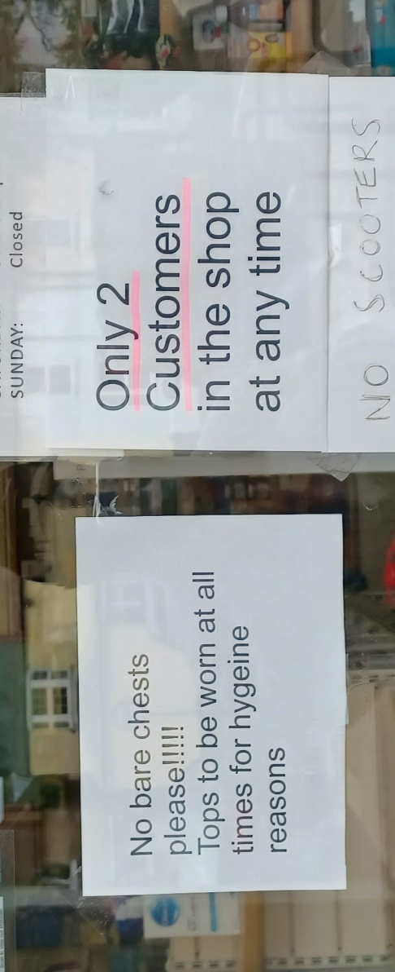
The Hitler complex gone mad!
Look at this ‘No bare chests please!!!!!’ warning we spotted on a chemist shop door in Wick, Littlehampton, West Sussex.
We saw that the store proprietor had stuck another announcement on their window about ‘masks to be worn at all times’, which we thought was fair enough considering face nappies are now compulsory in shops and takeaways; but this notice really takes the biscuit… in fact, the whole packet!
A good example we think, of how Covid 'rules' have turned Britain into a post-apocalyptic nation of petty Hitlers/jobsworths/Covsworths.
Many are on an orgasmic power trip with all of this. It is a wonder they are not wearing brown shirts and swastika armbands.
Bet they would, given half a chance.
Sieg Heil!

Please study the chart below.

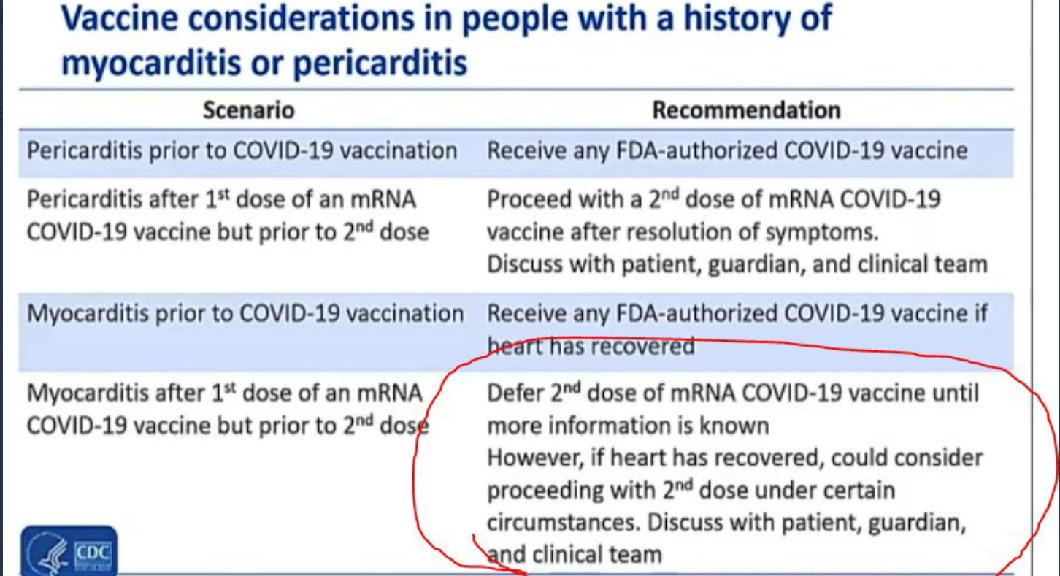
So, let’s get this straight.
If the first dose of Covid-19 mRNA vaccine has caused Myocarditis in the patient, the doctor could consider proceeding with a second dose anyway!
‘Vaxxers’ have wrecked the hearts of young men who had almost no risk of serious harm from Covid-19.
In our books this is pure wickedness!
Our illustration serves to show how corrupt many doctors are - and that they are a part of this scam/plan/hoax?
The pigs all have their snouts in the Covid trough.
Our government is shamelessly lining cronies pockets from the Covid scare.
Continual broken promises, meanwhile, they profiteer on a grand scale.
Why do we stand for such corruption?
And… we can see absolutely no point in voting either, as Labour and Liberals are now as one on the Covid issue.
Everything is rigged… from YouGov figures, crime statistics, unemployment figures, even the numbers of those vaccinated, and those being vaccinated, are exaggerated.
Government stats are as believable as Chinese state television.
These people need demonising, because now, more than ever before, it truly is, as they say, one law for them – and one law for us.
A person who really knows his onions concerning medical matters is a professional who we will simply call ‘Ben’; below he details just some of the many different ways a C-19 vaccine could harm people:
“1. Immediate anaphylactic (acute allergic) reactions to adjuvants in the vaccines known to historically cause problems.
2. Acute (within days to weeks) auto-immune reactions due to circulatory inflammation and antibodies causing low platelets and blood clotting problems. This would result in strokes, heart attacks and organ (liver, kidney) failure. Note that when these deaths occur suddenly in seniors, it’s often attributed to “old age” and no autopsies are done.
3. Delayed immune reactions (months to years later) due to pathogenic priming of the immune system by the vaccine. This was seen to happen when they tested previous mRNA vaccines in animals. Months later when the animals were exposed to a different strain of Coronavirus or even some other respiratory virus such as influenza, they responded with an overly aggressive immune response (called a cytokine storm) which resulted in widespread life-threatening inflammation in the lungs and major organs of the body. Expect the MSM to blame this on a new “more virulent” strain of virus, therefore raising the pressure to get more people ‘vaccinated’, (what a misnomer that is).
In reality, these deaths will actually have been due to a delayed side effect of the vaccine.
4. Long-term (over years) auto-immune diseases caused by “Covid antibodies” and T-cells cross-reacting to proteins within the body. Results could be an increase in conditions such as autism, juvenile diabetes, ADHD, OCD in kids, and inflammatory bowel disease, inflammatory arthritis, heart disease, multiple sclerosis, etc… in adults.
The other possible effects could be fertility issues in both men and women, which we’ve already been seeing with increased rates of in developed countries where vaccination rates are high. (E.G., lowered sperm counts with poor motility in men, endometriosis and increased miscarriages in women.) It is easy to predict these above health issues simply by looking at the design of the “vaccines”, which really are more properly described as “gene therapy”.
However, we also have the experimental data that was generated in animal trials when they were attempting to develop mRNA vaccines for the SARS virus… they abandoned these trials because most of the animals died when they were exposed to viruses a few months after vaccination.
Ben… at this point, it appears many people will be getting vaccinated, so I’m not going to try to warn people anymore.
It’s falling on deaf ears, and I risk alienating most of the people I know with my “conspiracy theories”.
I hope those of us doctors and scientists who’ve had grave concerns about these vaccines are eventually proven wrong.
I really do. I fear we won’t be.” [End]
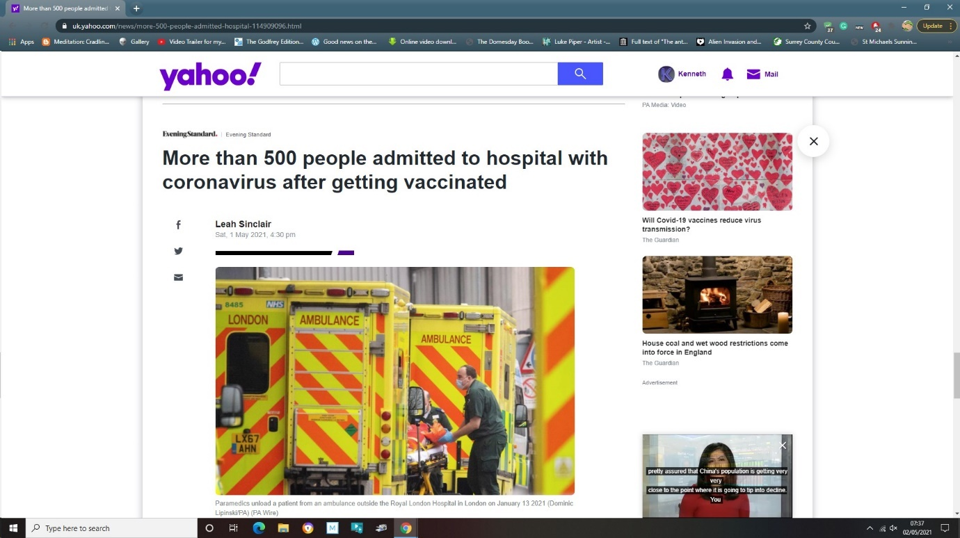
Whenever we look at the bleak and insensitive eyes of various people involved in the vaccination program, one thing becomes clear - they have no guilt, and perhaps, no soul either.
And some of those who have partaken of the concoction appear similar.
It’s not just our observation, plenty of others have noted that human behaviour has definitely changed since the beginning of 2021, with everything from domestic abuse, road rage, air rage - even *shop rage, all on the increase.
*August, 2021: Leaders of 100 brands including Tesco, Sainsbury’s, Ikea, Co-op and Aldi have called on the government for greater protection of retail workers after violent attacks on their staff by customers.
It’s like a madness suddenly comes over some people when triggered.
Maybe it’s due to the lockdown, we’re not sure – but just as likely it’s the result of mRNA ‘instruction’ synthetics coursing through people’s bodies.
A like-minded colleague of ours recently described watching those ambling around his local shopping centre as ‘faceless, programmed zombies’; and that in itself, simplifies the following two Bible quotations for us.
Zechariah 14:12: (shortened)
And this shall be the plague with which the Lord will strike all the peoples… their flesh will rot while they are still standing on their feet, their eyes will rot in their sockets, and their tongues will rot in their mouths.
Isaiah 26:19-20: (shortened)
Your dead shall live… and the earth will give birth to the dead.
Is what we claim absurd?
Well, just listen to George Orwell, a man ahead of his time… and these quotes are enough to cause any doubter to stop and think:
‘In a time of deceit telling the truth is a revolutionary act.’
‘Big Brother is watching you.’
‘Freedom is slavery.’
'Some ideas are so stupid that only intellectuals believe them.'
‘Who controls the past controls the future. Who controls the present controls the past.’
‘Doublethink means the power of holding two contradictory beliefs in one’s mind simultaneously and accepting both.’
‘If liberty means anything at all, it means the right to tell people what they do not want to hear.’
‘Power is in tearing human minds to pieces and putting them together again in new shapes of your own choosing.’
‘We know that no one ever seizes power with the intention of relinquishing it.’
‘People sleep peaceably in their beds at night only because rough men stand ready to do violence on their behalf.’
‘To see what is in front of one’s nose needs a constant struggle.’
‘A people that elect corrupt politicians, imposters, thieves and traitors are not victims, but accomplices.’
There is a full-blown, dictatorial assault on everyone's freedom of speech.
It's happening right now by the 'thought police'.
While certain pages no longer exist, Google’s algorithms, (the complex system used to retrieve data from its searches) ensures other items of extreme importance are deeply buried.
In recent time, they have made certain things less accessible… harder to find.
Silencing, by filtering out data with which they disagree, (termed ‘shadow banning’ or ‘stealth banning’) is another method being used.
Naturally, when pressed, those running the show will deny that such practices take place – but they do, (we have done our homework) and research shows it’s widespread across most major internet services.
WHISTLEBLOWING GP’S LETTER TO SIR SIMON STEVENS
Following the suspension of Hampshire GP Doctor Sam White by NHS England for publicly questioning Covid protocols, his solicitors Philip Hyland of PJH Law have fired off the following letter to Sir Simon Stevens, Chief Executive Officer of NHS England. The letter lays out accusations of unlawful actions by NHS executives, HM Government, SAGE, MHRA and other authorities.
This is huge, a must read for anyone who finds themselves in any way threatened by any public body over any aspect of the Covid crisis.
The Covid19 Assembly recently launched “Speak Out” a whistleblowing service to help give a platform and legal protection (through PJH Law) to those wishing to come forward with information or opinions on the government’s response to Coronavirus.
CEO of the Covid19 Assembly, David Fleming, says: “We welcome this letter from Doctor Sam White and PJH Law and hope it encourages other doctors and medical professionals to come forward. “Speak Out” will do everything we can to ensure that such bravery is rewarded with the best legal advice possible at no cost.”
In an open letter to the Health Secretary Matt Hancock, Dr John Lee, former professor of pathology at Hull York Medical School and Dr Clare Craig, who runs the Covid19 Assembly Covid Deaths Audit, call for the government to take steps in order to avoid any doubt regarding the future attribution of Covid deaths. The full text of the letter appears below:
An open letter to:
Matt Hancock, Secretary of State for Health and Social Care
Copied to:
Humza Yousaf, Cabinet Secretary for Health and Social Care, Scotland
Eluned Morgan, Minister for Health and Social Services, Wales
Robin Swann, Minister of Health, Northern Ireland
Dear Mr Hancock,
Re: Covid Deaths Recording
We call on you to change the way COVID deaths are recorded, so that the numbers can be clearly compared with previous years.
Every winter season has a wave of deaths above the summer baseline, the majority of which are attributable to respiratory viruses.
Unfortunately, COVID deaths have been counted in a way that is not comparable to previous recording of respiratory deaths. There are at least five differences:
Figures from 2019/2020 and 2020/2021 have been added together to give a cumulative total. This has never been done before.
Deaths directly due to COVID and deaths that occurred with the virus detected in a patient have been merged. Despite assurances that the very real difference between these two categories is officially understood, the two groups are presented as one number.
The criterion of attributing a COVID death on the basis of a positive test in the previous 28 days, even in the absence of symptoms of respiratory infection, is clinically dubious and has never previously been used.
We acknowledge the NHS recently adjusted criteria to define a COVID case to reduce overdiagnosis. These changes must apply to all people equally and ultimately apply to any subsequent deaths.
Mass testing for a respiratory virus has never previously been carried out on the scale used for COVID. It is well known that respiratory viruses are incidentally present in nearly half of all deaths, giving ample opportunity for misattribution of causes of death in a way which is not comparable to previous years.
Doctors deciding on a cause of death, knowing that a patient with a positive COVID test is already recorded by Government as a COVID death are inevitably under pressure to attribute death to COVID or mention it on the death certificate.
The inevitable exaggeration of deaths “due to” COVID has meant that all-cause mortality has to be analysed to give a true indication of the extent of the harm caused by the new coronavirus, rather than having a genuine direct measure of its impact. The gap between apparent COVID mortality and excess all-cause mortality since Autumn has been obvious.
In order to return to a measure that is comparable with respiratory virus deaths from previous years (e.g. due to influenza) it is important that the Government urgently takes the following steps:
Cease adding future COVID deaths to the historic tally, put aside the headline grabbing “COVID death toll”, and separate the 2019/20, 2020/21, 2021/22 and subsequent cohorts.
Advise doctors not to record COVID as a cause of death without sufficient clinical and laboratory evidence to defend that decision at inquest. A single positive test alone is not adequate evidence.
Ensure that post-mortems are carried out for a significant sample of clinically and laboratory confirmed COVID deaths.
Remove the criterion of “deaths within 28 days of a positive test” from all future counting of COVID deaths.
Many members of the public, politicians, and even medical professionals have a distorted understanding of the deaths that COVID has caused.
This is due to poor data quality acknowledged by the government from the outset, but compounded by the idiosyncratic, never previously used, and non-comparable way in which COVID deaths have been attributed.
Successful reopening of society requires dialling-down the fear of COVID which has been so successfully generated.
Presenting the COVID death data in a way that is comparable to previous years will be an important part of that.
Yours Sincerely,
Dr Clare Craig BM B
Dr John Lee BMBS PhD FRCPath [End]
TRUTH is always called a conspiracy theory by the mainstream media; it's their job to dumb down the masses. Yet, enough people subconsciously know what is going on - and we hope our research findings have helped clarify things by tying all the loose ends together for them.
Latest 02/07/2021:
To date, some 822,845 vaccine adverse reactions have been recorded in the United Kingdom, (alone) by the Medicines and Healthcare products Regulatory Agency (MHRA), together with 1,180 deaths. These figures are across all vaccine types, as detailed in the UK Column COVID-19 vaccine adverse effects analysis overview. Please note that the summary data shown is a presentation of the actual data taken from the UK Government MHRA Yellow Card vaccine adverse effects data itself. A big thanks to UK Column for pointing us in the correct direction regarding these figures.
News flash 03/07/2021… Some Facebook (FB) users in the United States are being served a prompt asking them if they are worried that someone they know might be becoming an extremist. Others are being notified that they may have been exposed to extreme content.
It is all part of a test that the social media company is running which stems from its Redirect Initiative, aiming to combat those with extreme views, Andy Stone, a Facebook spokesperson, told CNN.
"We are partnering with NGOs and academic experts in this space and hope to have more to share in the future," Stone added. Source CNN
‘Extremist’ = a person who holds extreme political or religious views.
In other words, thinking for yourself.
It is a blatant communist attempt at shutting down and criminalizing problematic people, who talk online about things that they (Big Brother) doesn’t like.
And make no mistake, they store data on all users… and will use the evidence against us when the time comes.
So, if you know anyone who fits their ‘extreme views’ bill, your friends or neighbours perhaps… go grass em’ up and grass em’ up real good!
Canada have introduced similar sweeping legislature, allowing government agencies there to intervene over “any communication that expresses detestation or vilification of any individual or group of individuals.”
Nice and vague, eh? just the way they like it, so that anyone, anything and everything is covered.
People ask us, so, is the New World Order coming? on every occasion we hear something like this, we feel like retorting ‘wake up and smell the coffee – it’s already here!’
When the CEO of Youtube’ openly talks about the need to censor things that are currently legal… namely censoring legal speech online, it goes without saying really that we had all better buckle up – it’s going to be a bumpy ride!
We’ve run the risk by publishing this book, in which we have exposed the pure evil that is dominating our planet; so, if we’re taken down or out – you know why!
A classic technique to watch out for, is for the global cult to blame antivaxxers and resistance groups for the harm they themselves are causing to society and the world.
Perhaps those who were previously unsure, will never think the same way again.
The Centers for Disease Control and Prevention, (CDC) have synthetically produced genetic material identical to that carried by the virus.
In a roundabout sort of way, the CDC have acknowledged that SARS-CoV-2 doesn’t really exist outside the vaccines being pumped into people through the inoculation program.
The CoV-19 virus photo you see reproduced, (which, with variations on the theme, and featured on promotions everywhere) is merely a computer rendering, a guesstimation of what they think this supposed virus would look like under an electron microscope.
It was built using 3-D modelling, which required a mix of research, (based on the aforementioned synthetics, along with other coronavirus in the same family as SARS-CoV) and any information gaps were bridged by hypothesis and artistic license.
“PCR is intended to identify substances qualitatively, but by its very nature is unsuited for estimating numbers. Although there is a common misimpression that the viral load tests actually count the number of viruses in the blood, these tests cannot detect free, infectious viruses at all; they can only detect proteins that are believed, in some cases wrongly, to be unique to HIV. The tests can detect genetic sequences of viruses, but not viruses themselves.” Source: John Lauritsen – of the IRF - Information Resource Foundation.
According to our own in-depth research, and despite many £$billions spent by governments and big pharma on flooding the internet with claims to the contrary, the full virus genome has not been purified or isolated.
It’s all guesswork and there is no proof that the alleged ‘Covid-19 virus’ actually causes the illness that it is claimed.
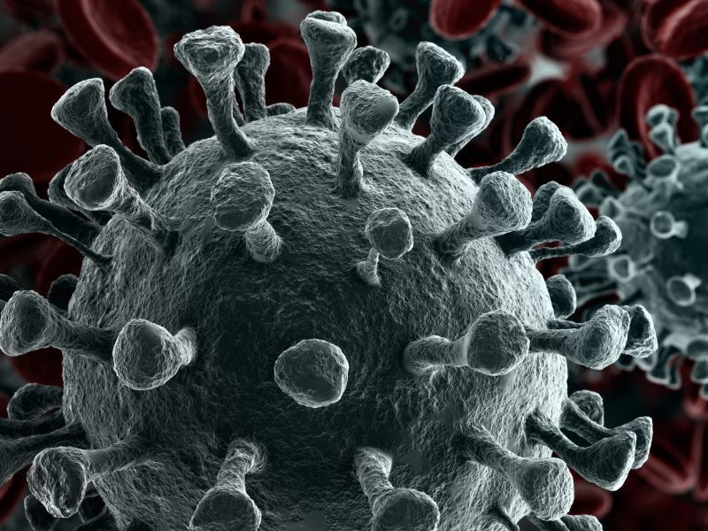
Furthermore, the test that is being used (the RT-PCR) should NEVER be used for diagnostics. So said its inventor Kary Mullis. This is because it is not a 'gold-standard' test that would give 100% accuracy.
In fact, there is a false positive rate of 80% for this test. This means that the test is meaningless as it is just testing for genetic material and not coronavirus and even that is only a real positive for one in five people. Other tests being used are as bad or even worse.
Using these tests anyone can test either positive or negative depending upon how many cycles the specimen is amplified by and as such the tests can be easily rigged. [quote by CrowdJustice]
Many politicians and advisers will admit privately that the policy change compelling people to wear masks was not really about the spread of infection at all but about the psychological effect that they would have.
That the real purpose is social control – to provide a constant reminder to maintain distance from other people. I believe the real purpose of masks is social control - it's time to turn down the fear dial, writes GRAHAM BRADY, Chairman of the Tory 1922 Committee.
Quote from MailOnline 17th July 2021.
Fox News personality Tucker Carlson questioned the legitimacy of Covid-19 vaccine advice, directly contradicting his co-stars on the same network who that day had urged viewers to get the jab.
In his Monday segment, titled “Our leaders want us to shut up and not ask questions”, Mr Carlson told viewers: “There are a lot of people giving you medical advice on television and you should ignore them.”
“There are a lot of those people giving you medical advice on television, and you should ignore them,” Mr Carlson said on his show. “The advice they’re giving you isn’t designed to help, it’s designed to make you comply. And you shouldn’t comply mindlessly. You’re an American adult. You’re allowed to ask simple questions and then demand clear answers. That’s why we live here. That’s your birthright. Jade Bremner - The Independent - 20 July 2021
New Jersey State Senator Declan O’Scanlon was silenced on Twitter and was only reinstated when he agreed to delete his tweet.
The tweet, posted on June 25, read “Given that we have crushed Covid with combination of natural immunity and voluntary uptake there is no reason anyone should be compelled to take the vaccine. Restrictions/mandates/vaccine passports all uncalled for.”
Twitter’s response to O’Scanlon’s Twitter post was to lock him out of his account without giving a specific reason as to why.
On Twitter, Republicans blasted the lawmaker’s detention.
The state GOP called the action a “continuous and rising limitation of freedom of expression.” Posted by Dan Frieth on Reclaim The Net.
“This comment has been blocked”, how many times have you come across this kind of thing when browsing through the comments section of online newspapers?
Of course, they leave alone the comments they don’t mind you seeing, unmoderated.
The comments that are removed or blocked are not all offensive either, (we know, we’ve tried with some really tame stuff) they can include anything that doesn’t fit in with ‘the narrative’… the official narrative.
Algorithmic fact-checking ‘bots’ sweep for key words that might be indicative of someone trying to air an opposing opinion.
And it’s like that in most places; Big Tech platforms have increased their censorship of so-called “COVID-19 misinformation”.
Free speech on the net now seems to be banned… only a few places survive Big Brothers’ eye of providence.
Australian legislators have proposed harsh penalties for people defying COVID measures, including $11,000 fines for people supporting and promoting anti-lockdown protests (termed “superspreading events”) online.
Out of the ordinary, considering how one type of largely peaceful protest is banned, while other rallies in Australia, such as Gay Pride, and counter-protests in support of government measures, are fully allowed to take place.
Is there is something that they’re trying to hide?
We find this censorship oh, so alien; you see, we are of an age where we remember in the UK, under Article 10 of the Human Rights Act 1998, everyone once had “the right to freedom of expression”. But the law did specify that this freedom “may be subject to formalities, conditions, restrictions or penalties as are prescribed by law and are necessary in a democratic society”.
And, under international human rights law, Governments can limit the exercise of most human rights if it is necessary to protect the rights of others or collective interests.
Taking full advantage of the exceptional circumstances brought about by the COVID-19 global “pandemic”, freedom laws have recently, (2021) been changed and assault on personal opinion… our right to be truly free, is now widespread.
Under government discretion, invasive and aggressive measures have now been adopted when it comes to freedom of speech.
Even aspects of the Geneva Convention have been voided because of the “public emergency threatening all human life on earth”.
Effective content moderation by automated algorithmic attack is affecting social platforms globally, suppressing content that someone on-high deems undesirable.
And ‘private’ websites are not immune either. Internet content is subject to technical censorship methods, including… Internet Protocol (IP) address blocking: Access to a certain IP address can be denied. If the target Web site is hosted in a shared hosting server, all websites on the same server will be blocked.
According to one study, two-thirds of all internet users – 67% – live in countries where criticism of the government, military, or ruling family is subject to censorship.
Never have governments taken such tight international control of our personal behaviour; politicians around the world are making it their business to control our opinions and conduct.
Every country has now introduced emergency laws; here in the UK we have in readiness, something previously known as the Online Harms Bill; this parliamentary proposal has been two years in the making.
Not only does it cover a huge range of content to which children might fall victim - including grooming, revenge porn, hate speech, images of child abuse and posts relating to suicide and eating disorders, but it goes much further… taking in terrorism, disinformation, racist abuse and pornography, too.
“Disinformation” can easily mean freedom of expression, one of the most important rights in a democracy.
If this legislation is passed and becomes law, then websites whose content contains views regarded as unacceptable or offensive, (criticism of the Royal family or any government for example) “legal but harmful” content can be remotely removed by law.
If such content is not removed, offending web hosting services/social media platforms would be reprimanded with fines or more severe punishments such as closure and/or imprisonment, even if that content is deemed ‘lawful’.
This means that websites can be swiftly taken down, site owners fined and blacklisted, social media users banned/deplatformed… all on the say-so of someone in authority.
But we have a mental block about all of this and just can’t accept what is happening; world wars have been fought for our liberty in which millions died, and now those rights are just obliterated as if they never existed?... come on now.
We find it all very suspicious to say the least, why those in various corridors of power around the world plan to implement this and similar acts at all; because our right to freedom of expression used to be enshrined in laws worldwide; however, behind our backs, almost on a weekly basis, in a coordinated fashion, these historic laws are being overturned by authoritarian governments globally, on what seems to be the introduction of a New Order.
From the outset of this crisis, the British Government have identified two types of “harm” they wish to tackle online: illegal content and what they describe as “misinformation”.
In the UK it was once stated in Article 10 of the Human Rights Act (1998) “Everyone has the right to freedom of expression. This right includes freedom to hold opinions and to receive and impart information and ideas without interference by public authority and regardless of frontiers.”
In the US, they once had the Constitution, which established America's national government and fundamental laws and guaranteed certain basic rights for its citizens. It was signed on September 17, 1787, by delegates to the Constitutional Convention in Philadelphia.
But authorities in Congress are close to radically altering the Bill of Rights, all under emergency Coronavirus Pandemic powers.
The First, Second, Fourth, Fifth, Sixth, Eighth, and Tenth Amendments are now under severe attack.
Clearly our way of life has already changed for the worst and is about to change even more dramatically over the coming months as our human rights are eroded.
22/07/2021: Today, vaccines minister Nadhim Zahawi laid out plans for a UK-wide NHS Covid pass which will allow people to show their Covid status, which is surely an I.D. card by any other name.
We have been told that us making comparisons of what is currently happening in the UK and worldwide, to Nazi Germany is ‘conspiracy’ fantasy, ‘tinfoil hat stuff’… just plain ‘lazy’ journalism; but is it really?
Next is a document from Nazi occupied France, stating all the establishments that Jewish people were forbidden from frequenting…
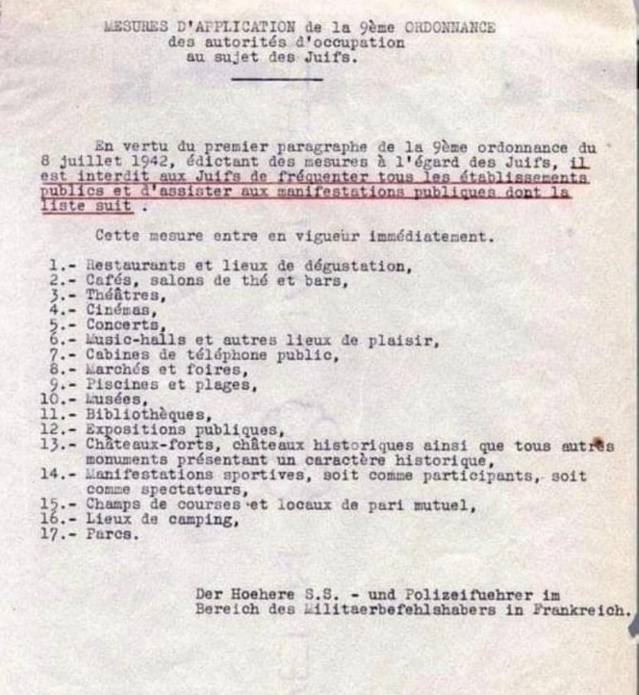
Kwasi Kwarteng, UK business secretary, said he was confident the government would win an expected parliamentary vote on vaccine passports.
We have tiptoed into tyranny.
People attending the following venues in England will have to be fully vaccinated against Covid by the end of September, the government has said and will require an NHS Covid Pass.
This will soon become a legal requirement.
The ‘pass’ will have to be shown before entering such crowded places as…
- Nightclubs
- Pubs
- Cinemas
- Football grounds
- Snooker clubs and tournaments
- Indoor Tennis matches
- Indoor School events
- Supermarkets/Shops/Restaurants
Very Latest News. Now, according to Reclaim The Net, French legislators have ignored widespread protests and passed a law requiring all residents over the age of 12 to produce COVID-19 vaccine passports to travel, visit a restaurant, and other normal life activities. Opponents to the law have said they will continue protesting.
The controversial law was passed on Monday, following an all-night session involving both houses of the French legislature. From August, all adults will have to follow the new vaccine passport rules, which will extend to kids as young as 12 by the end of September.
According to a report by France 24, museums, restaurants, and even swimming pools will be required to demand vaccine passports, displaying a person’s vaccination status, recent negative tests, or recent recovery. The passports will also be required for travel by plane and train.
Any venue hosting more than 50 individuals will be required to demand vaccine passports, or face ridiculous fines.
So, is this partly what it has been about all along - getting a compulsory ID card, (or identity document) through by stealth? 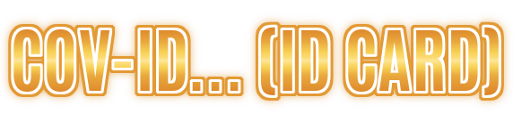
COV ID-19… (and remember the implantable RFID chip mentioned earlier?) considering how the illuminati just love their symbolism… (and to parade it) the 19 may well stand for ‘AI’ (1 being the letter A in the English alphabet, 9 being the letter I).
Or is this just another coincidence?
We tend to go along with what Albert Einstein said – “there is no such thing as coincidence in this world — there is only inevitability”.
But what about all the Covid deaths? we hear some people shout.
What about them?
Plenty of patients with undiagnosed comorbidities, die with it – not from it.
More Fact Checks: Testing is performed using 40 cycles of amplification as part of the RT-PCR process… way beyond the recommended threshold, where even a piece of fruit can test positive.
Also, pay close attention to the “death occurred within 28 days of a positive COVID-19 test” con.
Note also, how there are very rarely any autopsies performed on those who allegedly died “with” Covid-19.
Not forgetting either, the Covid shots are not true vaccines, (but more in the way of instructional synthetics) and by all accounts they maim and kill.

Read all about it! extra…
A nanoluciferase SARS-CoV-2 for rapid neutralization testing and screening of anti-infective drugs for COVID-19
https://www.nature.com/articles/s41467-020-19055-7
Abstract
A high-throughput platform would greatly facilitate coronavirus disease 2019 (COVID-19) serological testing and antiviral screening. Here we present a high-throughput nanoluciferase severe respiratory syndrome coronavirus 2 (SARS-CoV-2-Nluc) that is genetically stable and replicates similarly to the wild-type virus in cell culture. SARS-CoV-2-Nluc can be used to measure neutralizing antibody activity in patient sera within 5 hours, and it produces results in concordance with a plaque reduction neutralization test (PRNT). Additionally, using SARS-CoV-2-Nluc infection of A549 cells expressing human ACE2 receptor (A549-hACE2), we show that the assay can be used for antiviral screening. Using the optimized SARS-CoV-2-Nluc assay, we evaluate a panel of antivirals and other anti-infective drugs, and we identify nelfinavir, rupintrivir, and cobicistat as the most selective inhibitors of SARS-CoV-2-Nluc (EC₅₀ 0.77 to 2.74 µM). In contrast, most of the clinically approved antivirals, including tenofovir alafenamide, emtricitabine, sofosbuvir, ledipasvir, and velpatasvir were inactive at concentrations up to 10 µM. Collectively, this high-throughput platform represents a reliable tool for rapid neutralization testing and antiviral screening for SARS-CoV-2.
Please go “Fact Check” this… it’s absolutely real.
Why on earth would medical science use the name of ‘Lucifer’ for anything in connection with the alleged SARS-CoV-2 virus?
Evil? or Accident? Go figure.
One last sobering thought: “Most COVID deaths in England now are in the vaccinated – but here’s why that shouldn’t alarm you. More vaccinated people are dying of COVID than unvaccinated people, according to a recent report from Public Health England
https://www.gov.uk/government/publications/investigation-of-novel-sars-cov-2-variant-variant-of-concern-20201201
(PHE). The report shows that 163 of the 257 people (63.4%) who died of the delta variant within 28 days of a positive COVID test between February 1 and June 21, had received at least one dose of the vaccine. At first glance, this may seem alarming, but it is exactly as would be expected.
“The fact that more vaccinated people are dying than unvaccinated people does nothing to undermine vaccine safety or effectiveness. In fact, it’s exactly what we’d expect from the excellent vaccines, which have already saved tens of thousands of lives. “
Source: The Conversation - Academic rigour, journalistic flair
Christian Yates, Senior Lecturer in Mathematical Biology, University of Bath July 15, 2021
Latest Headlines 21/11/2021
Google’s parent, Alphabet, is already deeply embedded in the medical industry, but is expanding with a new subsidiary, Isomorphic Labs. The company will attempt to discover the “common underlying structure between biology and information science”, in a quest to accelerate new drug discovery. It will partner with pharmaceutical and biomedical companies. ⁃ Tech News.
Here’s another.
“Huge spike in people left to die at home – rotting corpses not found for ‘weeks’ during pandemic and lockdown instigated for your ‘health’ 19/11/2021 Source MSN.
https://www.msn.com/en-gb/health/mindandbody/huge-spike-in-people-left-to-die-at-home-and-not-found-for-weeks-during-pandemic/ar-AAQUfwQ?ocid=winp-se
And another
Myocarditis cases through the roof Mrs Qld Premier from an inoculation that does not work
19/11/2021
Posted by Editor, cairnsnews
Today the Leader of the United Australia Party has written to the head of the TGA, Professor John Skerritt following a very significant surge in Myocarditis & Pericarditis cases reported to the TGA’s Database of Adverse Event Notifications (DAEN), seeking an explanation for this dramatic and alarming surge.
June 2021 : 39 cases
July 2021 : 121 cases
Aug 2021 : 283 cases
Sept 2021 : 519 cases
Oct 2021 : 813 cases
Further, this alarming trend appears to be continuing with a total of 83 cases reported for just the first two days of November 2021.
Mr Kelly is looking forward to receiving the TGA’s urgently reply to explain the reason behind this dramatic increase in reported cases.
Editor: Good luck Craig with getting a reply from the big pharma-controlled TGA
A-nother!
Food as a Weapon: Starving Us into Submission
“It does not take an agronomist, far less a rocket scientist, to realize that carbon dioxide is necessary for plants to grow. For plants it is the breath of life; they breathe carbon dioxide as we breathe oxygen. We exhale the carbon dioxide they need, while they exhale the oxygen we need.” S. M. Smyth
Remember, too, that at a time when people are very concerned with their health and its relationship to what they eat, we have handed over the responsibility for our nourishment to faceless corporations. ― Lynne Rossetto Kasper
GM has never been about feeding the world or tackling environmental problems. It is and has always been about control of the global food economy by a tiny handful of giant corporations. It’s not wicked to question that process. It is wicked not to. — Zac Goldsmith
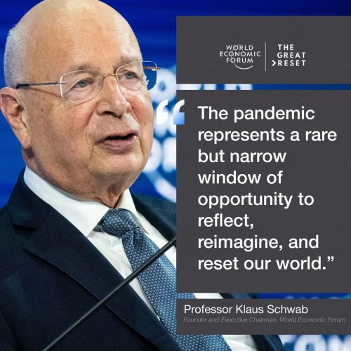

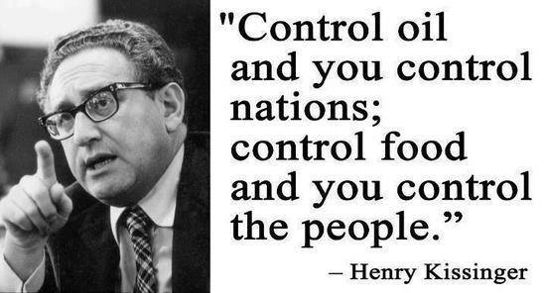
It is now necessary to reorganize society. To this end, an Authority must be created with the power to control human population, to redistribute food, to purify air, water, soil, to re-pattern the cities. — Gore Vidal
Would food be considered an instrument of national power? . . . Is the U.S. prepared to accept food rationing to help people who can’t/won’t control their population growth? — Henry A. Kissinger
Source: Global Research 15/11/2021
And the news keeping on coming…
22/11/2021: We read that PZP is used to sterilise wild horses in America. The first 2 doses must be taken within 2 to 6 weeks apart with a 8 month to yearly booster follow up. This reduces pregnancy rate 80%-90%.
Something about the schedule sounds familiar. Pfizer CEO is also a veterinarian… how convenient!
This is a potential nail in the coffin for Pfizer – SpayVac’s DPX lipid nanoparticle delivery system.
SpayVac produces the PZP infertility vaccine. They licensed their DPX lipid nanoparticle delivery technology to Pfizer for them to make the COVID vaccine.
The PZP vaccine doesn’t cause immediate sterility – it takes over a year to appear. (Funny, Pfizer only studied a few months.) But PZP causes short term menstrual cycle changes as the immune system attacks the ovary cells. The SAME menstrual changes are being seen in women WORLDWIDE!
We are trying to end this book somewhere… but where! Would it surprise you to learn that vaccine injury lawyers are booming, although they won’t tell you that on MSM, there’s dozens of em’ popping up in every country... go Google it if you don’t believe it.
Compensation funds have been set up by governments… but those are only for those who have survived, (for now), thousands weren’t so fortunate.
Yet mainstream media continue to say these vaccines are perfectly safe and side effect are “rare”… lies damn lies!
But why?
Your GP knows that the shots ain’t safe… many medical staff know this as well… they won’t even have the jabs themselves!
Here are just a few compo’ claims people we pulled off Google images…
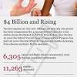vaccine court
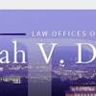leah durant
compensation program
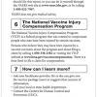flu vaccine administration
leah v durant
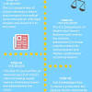national vaccine
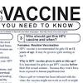immunization
mmr vaccine
vicp
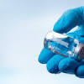side effects
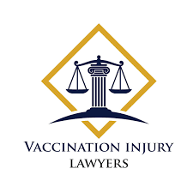
Vaccine Injury Lawyers
vaccinationlawyer.com

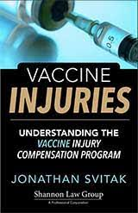
Understanding the Vaccine Injury Program
shannonlawgroup.com

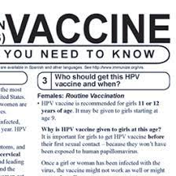
Vaccine Injury Compensation Programs ...
historyofvaccines.org

Vaccine Injury Law Project - Home ...
facebook.com

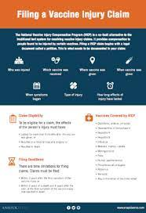
A Vaccine Lawyer and VICP Claims
anapolweiss.com

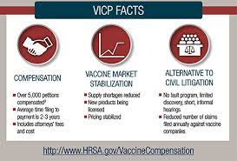
Vaccine Injury Payouts | MCTLaw ...
mctlaw.com

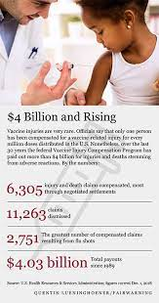
Federal Vaccine Court Quietly Pays Out ...
fairwarning.org

Vaccine Injury Compensation
mctlaw.com

National Vaccine Injury Compensation ...
vaccineinjurylawproject.com

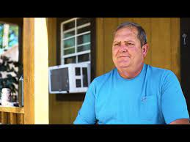
Attorney Leah Durant | Vaccine Lawyer
vaccinelaw.com

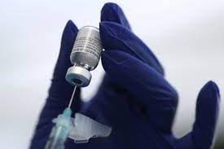
COVID vaccine injury claims ...
reuters.com

The Vaccine Injury Compensation Program ...
shotofprevention.com

Vaccine Injury Lawsuits: Can Vaccines ...
lawyer-monthly.com

Experienced Vaccine Injury Lawyers ...
vaccineinjurylegalteam.com

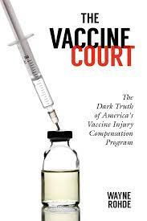
Vaccine Injury Compensation Program ...
amazon.co.uk

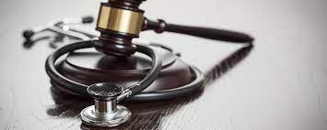
Vaccine Injury Law Attorneys ...
vaccineinjurylawproject.com

My Vaccine Lawyer Reviews, Client ...
myvaccinelawyer.com

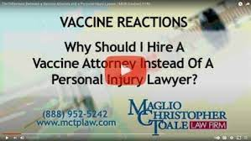
Attorney for your Vaccine Injury Case ...
mctlaw.com

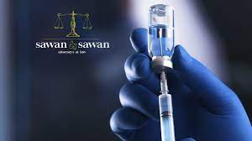
Vaccine Injury Lawyer | Sawan & Sawan ...
sawanandsawan.com

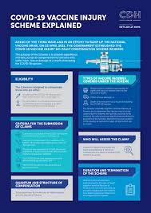
COVID-19 Vaccine Injury Scheme explained
cliffedekkerhofmeyr.com

Vaccine Injury Compensation Program ...
usvaccinelaw.com

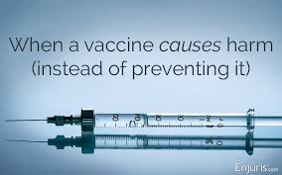
Vaccine Injury Claims: How Do I Get ...
enjuris.com

Vaccine Injury Law Project - Home ...
facebook.com

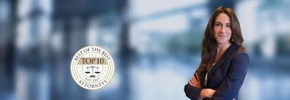
Vaccine Injury Lawyer | New Jersey ...
widmanlawfirm.com

Vaccine Court: The Law and Politics of ...
amazon.co.uk

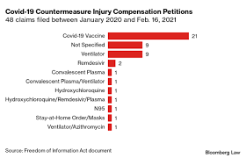
Covid-19 Vaccine Recipients Face Injury ...
news.bloomberglaw.com

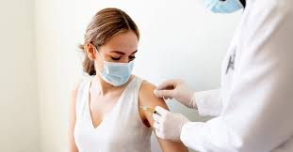
Injured by a COVID Vaccine? Want ...
childrenshealthdefense.org

Experienced Vaccine Injury Lawyers ...
vaccineinjurylegalteam.com

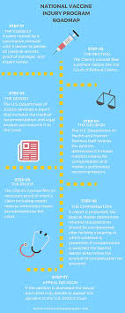
Illinois Vaccine Injury FAQs
shannonlawgroup.com

Cook County Vaccination Injury Lawyer ...
newlandlaw.com

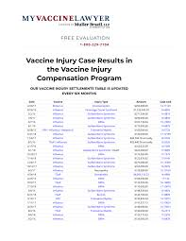
Muller Brazil attorneys at law VICP ...
vaccine.guide

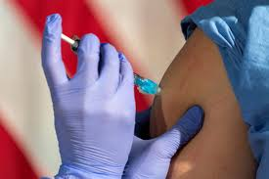
Covid vaccine: You can't sue Pfizer or ...
cnbc.com

vaccine injury compensation scheme ...
lawyersweekly.com.au

Covid-19 Vaccine Injury Compensation ...
biicl.org

a Vaccine Injury ...
vaccinelaw.com

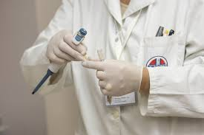
Thought Leader – Vaccine Injury – MC&T ...
lawyer-monthly.com

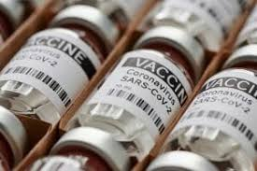
COVID-19 Vaccine Injury Compensation ...
mctlaw.com

Vaccine Injury Law Firm
ccandh.com

Vaccine Injury Help Center | Vaccine ...
vaccineinjuryhelpcenter.com

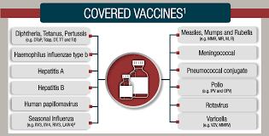
Vaccine Injury Compensation Program ...
myvaccinelawyer.com

Vaccine Injury Lawyer ...
howielaw.net

Vaccine Injury Lawyers | Groth Law Firm
grothlawfirm.com

COVID-19 vaccine injury concerns create ...
11alive.com

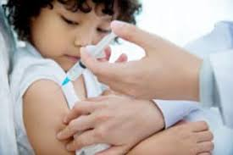
Vaccine Injury Lawyers | Rosen Injury ...
roseninjurylawyers.com

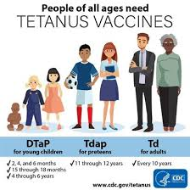
Tetanus Vaccine Injury Lawyers
vaccineinjuryteam.com

How Can A Vaccine Injury Lawyer Help Me ...
malloy-law.com

Related searches

before and after vaccine damage

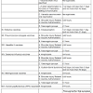
vaccine injury symptoms
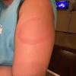
hard red lump after vaccination

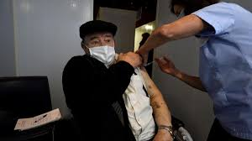
1 day ago
injured by vaccinations ...
thetimes.co.uk

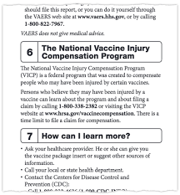
Vaccine Injury Claims Are Few and Far ...
nytimes.com

Vaccine Injury Lawyers - Zgheib Sayad ...
facebook.com

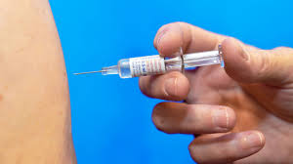
leading vaccination-related injury ...
science.org

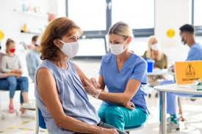
Covid-19 Vaccine Injuries and the ...
vaccineinjurylawproject.com

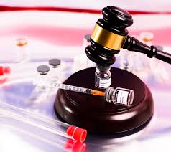
Vaccine Injury | Liberty Lawyers | Long ...
thelibertylawyers.com

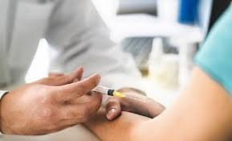
How to Find a Vaccine Injury Attorney ...
mintzlawfirm.com

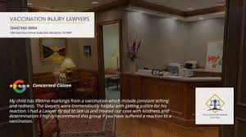
Vaccine Injury Lawyers
vaccinationlawyer.com

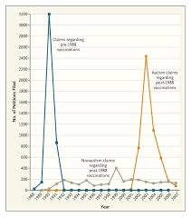
Legal Battles over Vaccines and Autism ...
nejm.org

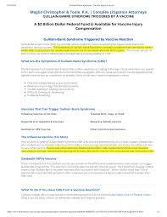
Vaccine injury compensation ...
vaccine.guide

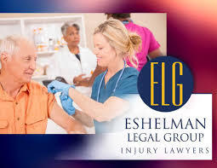
Vaccine Injury Compensation | Personal ...
eshelmanlegalgroup.com

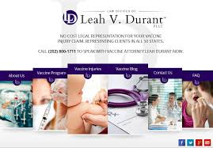
Representing Vaccine Injury Claims ...
vaccinelaw.com

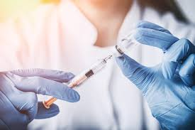
Lawyers Urge Use of 'Vaccine Court ...
insurancejournal.com

Vaccine Injury Law Firm
ccandh.com

Vaccine Injury ...
feedreader.com

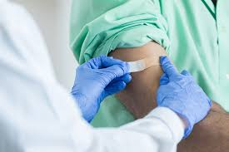
Maui Vaccine Injury Attorney | Menzer ...
maui.menzerlawfirm.com

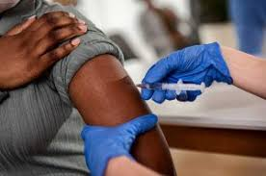
What Is the Vaccine Injury Table (and ...
shannonlawgroup.com

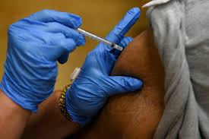
COVID vaccine injury claims mount, but ...
reuters.com

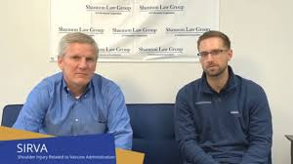
SIRVA | Vaccine Injury Lawyer ...
youtube.com

National Vaccine Injury Lawyer | Andrew ...
nationalvaccineinjurylawyer.com

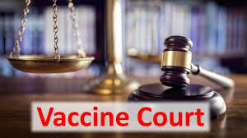
Vaccine court myths – instead, here are ...
skepticalraptor.com

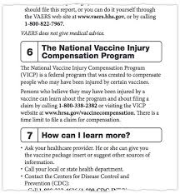
Vaccine Injury Claims Are Few and Far ...
nytimes.com

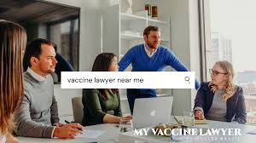
Max Muller Wins Compensation for Woman ...
myvaccinelawyer.com

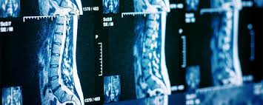
Transverse Myelitis Injury Attorneys ...
vaccineinjurylawproject.com

Related searches
polio
edward jenner

polio vaccine

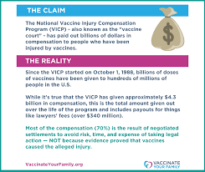
The U.S. National Vaccine Injury ...
m.facebook.com

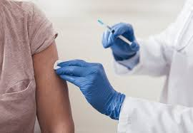
Vaccine-Related Injury
vaccinationlawyer.com

Attorney Leah Durant | Vaccine Lawyer
vaccinelaw.com

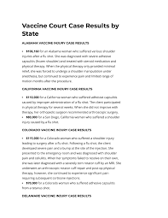
Muller Brazil attorneys at law VICP ...
vaccine.guide

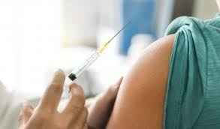
Vaccine Injury Lawsuits: Can Vaccines ...
lawyer-monthly.com

Illinois Vaccine Injury FAQs
shannonlawgroup.com

Vaccine Injury Compensation
mctlaw.com

Seven ways to talk to anti-vaxxers ...
healthydebate.ca

Vaccine Lawyer, Flu Shot Injury, SIRVA ...
myvaccinelawyer.com

SIRVA Injury Compensation Lawyers ...
vaccineinjurylawproject.com

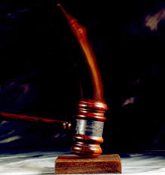
Vaccine Injury Court: Here's the Truth ...
time.com

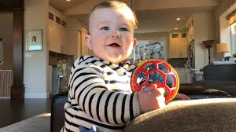
Vaccine Injury Compensation Program ...
theatlantic.com

Vaccine Injury Lawyers, Zgheib Sayad, P ...
linkedin.com

Vaccine Injury Litigation | GW Law ...
law.gwu.edu

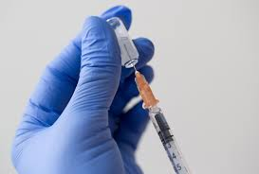
COVID-19 Vaccine Injury Claims ...
insurancejournal.com

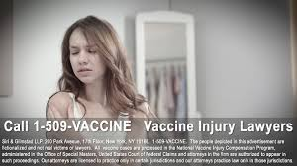
The Vaccine Injury Lawyer
facebook.com

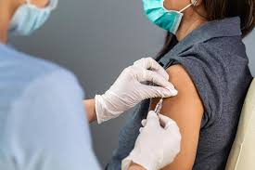
What Happens with a Vaccine Injury ...
neinstein.com

Diphtheria Vaccine Injury Lawyers and ...
vaccineinjurylaw.com

Vaccine Injury Claims Are Few and Far ...
nytimes.com

Vaccine Injury Attorneys | Michael ...
pisanchynlawfirm.com

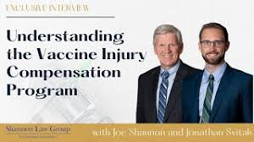
Vaccine Injury Lawyer ...
youtube.com

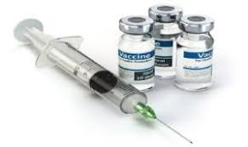
Vaccine Injury Lawyers In Durham, NC ...
jglawnc.com

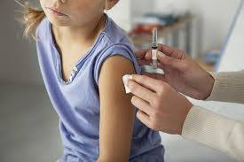
vaccine-injured children ...
news.stanford.edu

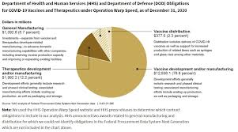
U.S. seeks to boost vaccine supply and ...
jdsupra.com

Related searches
lump on baby's leg after vaccination
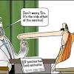
vaccine side effects cartoon

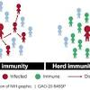
herd immunity

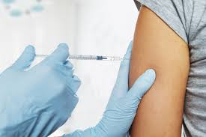
Vaccine Injury – Burdette Law
burdettelaw.org

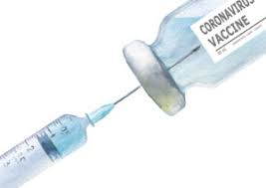
Vaccine Injury Law Firm
ccandh.com

What Is the Vaccine Court and How Does ...
verywellhealth.com

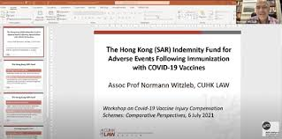
Covid-19 Vaccine Injury Compensation ...
hk-lawyer.org

What Is the Vaccine Court and How Does ...
verywellhealth.com

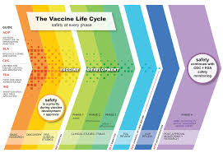

U.S. Vaccine Safety - Overview, History ...
cdc.gov

Vaccine Injury Law Firm | VICP Attorney ...
howielaw.net

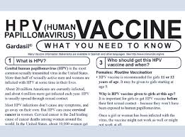

Vaccine Injury Compensation Programs ...
historyofvaccines.org

Modernize Vaccine Injury Compensation ...
law.gwu.edu

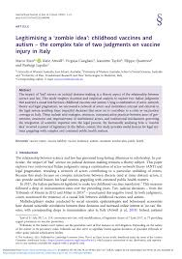

And we could go on practically ad infinitum.
If the ‘vaccines’ are safe – then why so many compensation specialists?
08/11/2021 noticing how Facebook just changed their name to ‘META’, prompted us to write a little bit about a new world being created so that people can act out the things of their hearts, their fantasies, (which let’s face it, will turn out to be mostly vile and barbaric) without consequences; one might say, very much in the style of demons!
To prepare us, (and this is being done in tiptoe steps), kids and adults are now encouraged, (almost subliminally) to destroy their moral compass; to allow minors to become sexualized, servile, obedient, submissive, and taught to embrace AI, artificial intelligence…
More and more will be trained to live in fear of the real world and encouraged instead to go live in an augmented reality through VR headsets... and even taught to interact with artificial intelligence entities, and how to escape the true, (and increasingly horrific) realities of the real world.
It has become so commonplace that you may not even notice it anymore, the often 'subtle' (and sometimes not so subtle) techniques that the media (the internet, television, newspapers etc) are using for our gradual introduction to this ‘alien world.
They call it education… we call it something else; we see it as downright creepy… the indoctrination/brainwashing, mind-programming of people!
The simple fact is they, (our controllers), want a large percentage of us useless eaters either disabled, dumbed down or better still, DEAD!
We have conducted a great deal of research about the Covid issue; this is just our take on it all… our point of view - please make up your own mind.
Thanks for looking at the evidence we have presented.
Ken and Hil
Email: research681@hotmail.com
The reset world might look the same – but under this global governance of demons in suits, it is becoming more like a mere cardboard cut-out of how things used to be… not so very long ago.
Educational - a not-for-profit book.
The End

Or is it?

Dr Andrew Kaufman: Medical Doctor & Forensic Psychiatrist from the USA
“I’m a medical doctor and board-certified forensic psychiatrist. This pandemic is not a real medical pandemic. The COVID-19 vaccine is not proven safe or effective because there has not been enough time.”
Dr Andrew Kaufman has been very outspoken about the fact that the Coronavirus is not a virus. He claims, “that what scientists were actually seeing with their electron microscopes was not a new coronavirus but rather exosomes”.
There has not been a virus that has been purified or shown to be the cause of an illness. Thus, there is no target for a vaccine
Dr. Andrew Kaufman
Dr. Hilde de Smet – Belgium
“I’d like to say that the new COVID-19 vaccine is not safe, and that there is no global medical pandemic.”
Dr. Nils R. Fosse – Norway
The COVID-19 vaccine has not been proven safe and effective. It’s a new technology and it’s been tested on a few 1000s of people in a few months. Please do your own research. This is not a real medical pandemic
Dr. Elizabeth Evans – UK
The COVID-19 vaccines are not proven to be safe or effective. We believe that it is reckless and unnecessary to roll out these essentially experimental vaccines that are using a completely new mRNA technology to millions of people when there is only limited short-term safety data, no evidence that they will prevent transmission of the virus,
Dr. Vernon Coleman – UK
The whole COVID-19 scam is, as I said in March 2020, the greatest hoax in history
Prof. Dolores Cahill | Molecular Biologist and Immunologist – Ireland
We know that we can treat the symptoms of COVID-19 very successfully with vitamins D, C, and zinc, and with very safe medicines.
[…] And also, a vaccine is then also not necessary. There has never been a license RNA vaccine.
Dr. Johan Denis – Belgium
The Corona vaccine is not proven safe or effective. There is no medical emergency. It is a fake pandemic. The Coronavirus is in terms of harmfulness mortality and transmissibility comparable to the seasonal flu.

